IKEA
The Wonderful Everyday – Wireframes v7.0
Nicolas Le Clainche – Nicolas@uxconsult.com
07/04/16

Table of Contents
1. Pages 5
1.1. Campaign sitemap 6
1.1.1. User Interface 6
1.2. Campaign mechanic 7
1.2.1. User Interface 7
1.3. Homepage 8
1.3.1. User Interface 8
1.3.2. Video Panel 9
1.3.2.1. State1 9
1.3.2.2. User Interface 9
1.4. Homepage w/quote 10
1.4.1. User Interface 10
1.4.2. Video Panel 11
1.4.2.1. State1 11
1.4.2.2. User Interface 11
1.5. Campaign landing page - Phase 1a 12
1.5.1. User Interface 12
1.5.2. more secrets 13
1.5.2.1. State1 13
1.5.2.2. User Interface 13
1.6. Campaign landing page - Phase 1b 14
1.6.1. User Interface 14
1.6.2. more secrets 15
1.6.2.1. State1 15
1.6.2.2. User Interface 15
1.7. Campaign landing page - Phase 2 16
1.7.1. User Interface 16
1.8. Campaign landing page - Phase 3 17
1.8.1. User Interface 17
1.9. Social media sharing - Flow 18
1.9.1. User Interface 18
1.10. Share secret - Facebook window 19
1.10.1. User Interface 19
1.11. Share secret - Shared Facebook post 20
1.11.1. User Interface 20
1.12. Share secret - Twitter window 21
1.12.1. User Interface 21
1.13. Share secret - Shared Tweet 22
1.13.1. User Interface 22
1.14. Ideas 23
1.14.1. User Interface 23
1.15. Ideas - Themes filtering w/mask 24
1.15.1. User Interface 24
1.16. Ideas page - Wonderful everyday themed ideas cluster 25
1.16.1. User Interface 25
1.17. Idea - Item 26
1.17.1. User Interface 26
1.18. Room page 27
1.18.1. User Interface 27
1.19. Product category 28
1.19.1. User Interface 28
1.20. Sub-category 29
1.20.1. User Interface 29
1.21. Product item - Option 1 (recommended) 30
1.21.1. User Interface 30
1.22. Product item - Option 2 31
1.22.1. User Interface 31
1.23. Product category 32
1.23.1. User Interface 32
1.24. Sub-category 33
1.24.1. User Interface 33
1.25. Product item (not recommended as this may break the flow of the page) 34
1.25.1. User Interface 34
1.26. Box room challenge page (x3) 35
1.26.1. User Interface 35
1.27. OLAPIC UGC Gallery 36
1.27.1. User Interface 36

- Pages
  - Campaign sitemap
    - User Interface
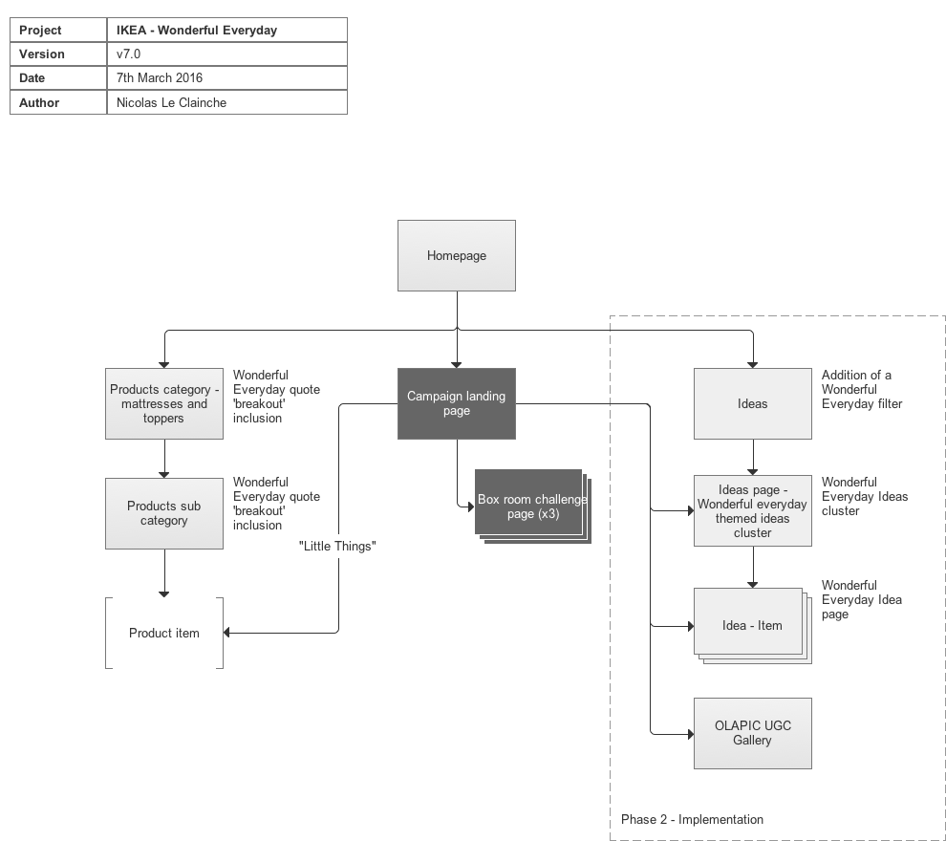
  - Campaign mechanic
    - User Interface
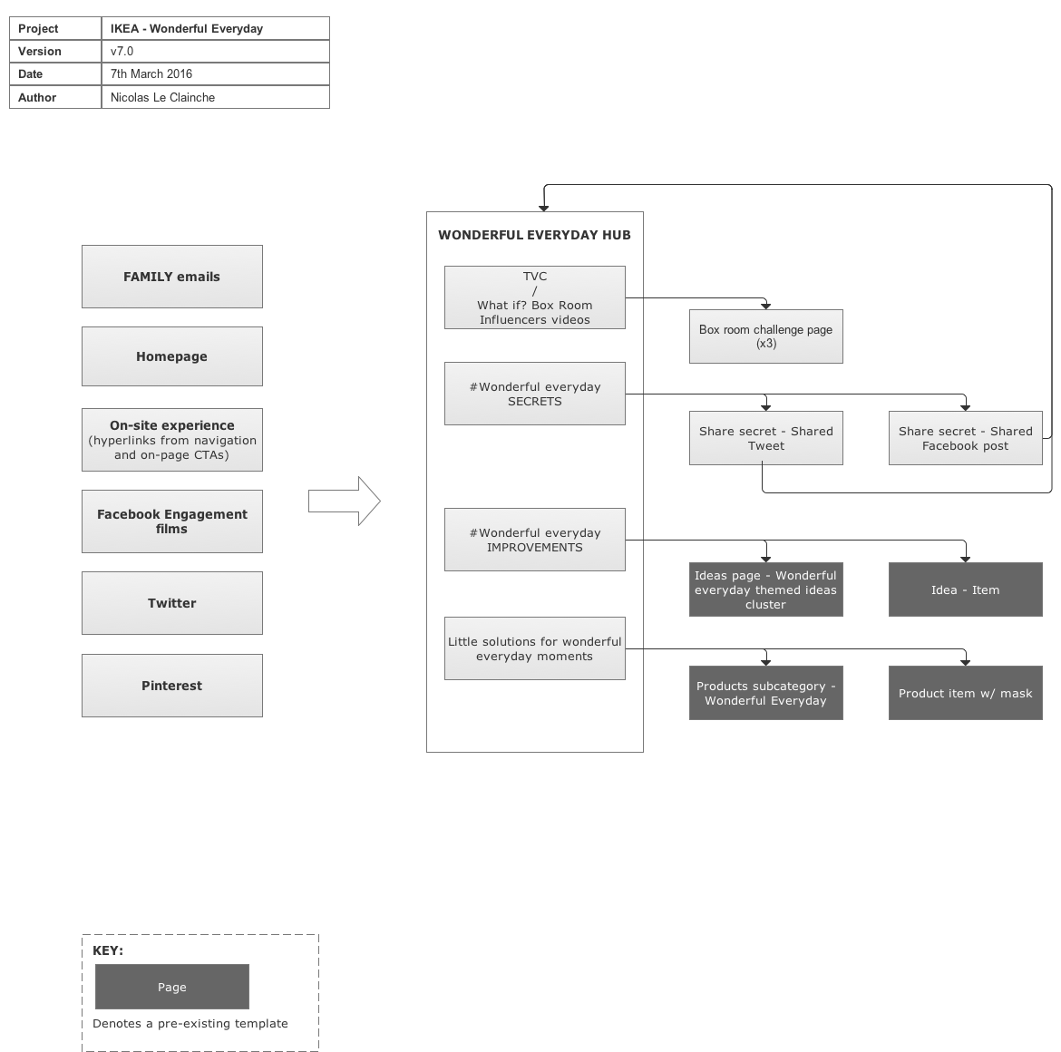
  - Homepage
    - User Interface
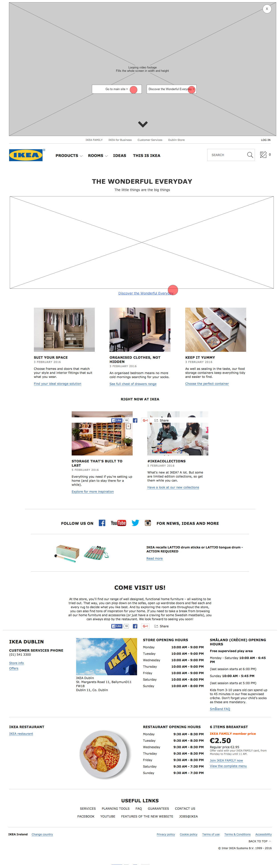
    - Video Panel
      - State1
      - User Interface
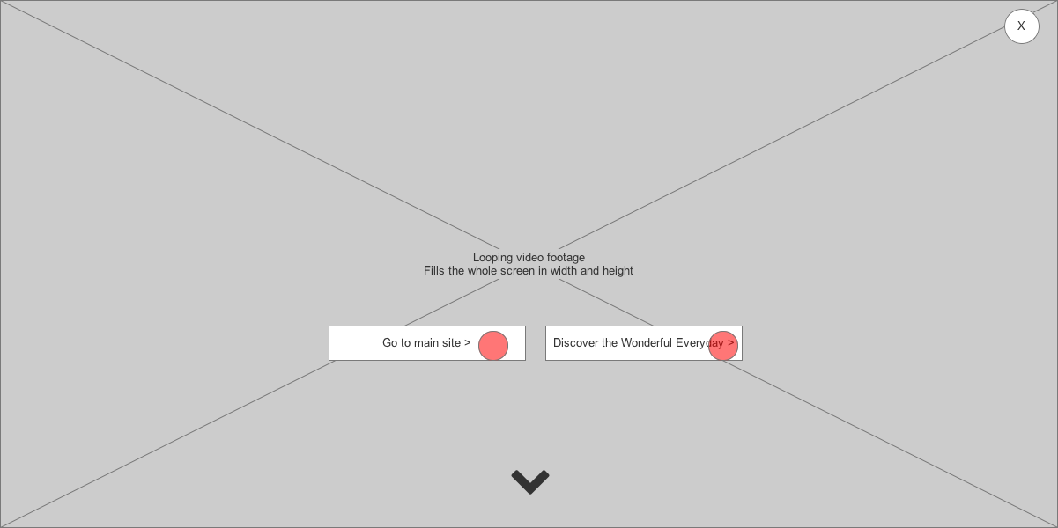
  - Homepage w/quote
    - User Interface
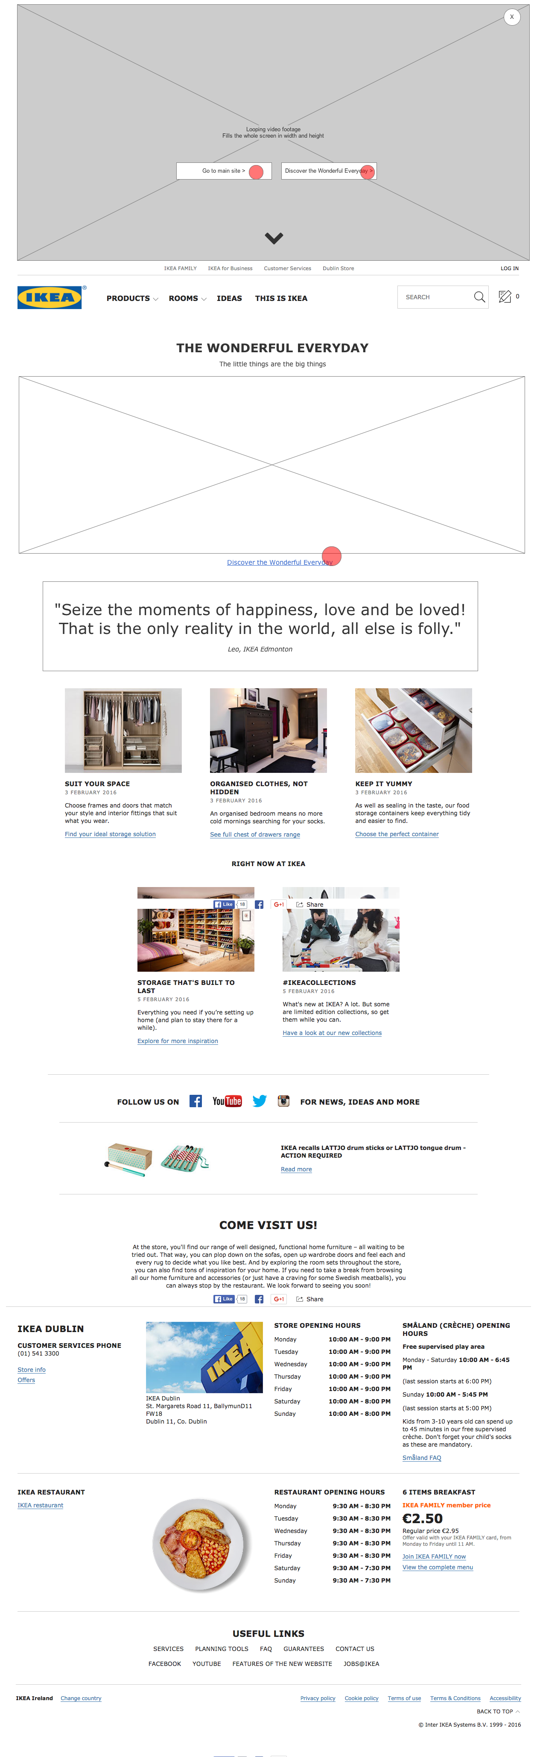
    - Video Panel
      - State1
      - User Interface
  - Campaign landing page - Phase 1a
    - User Interface
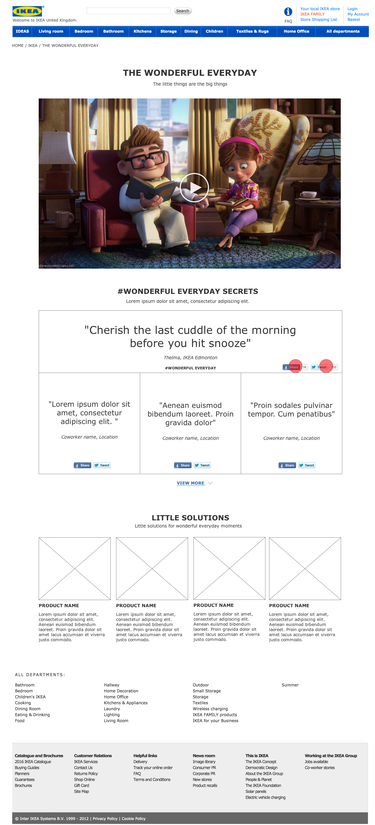
    - more secrets
      - State1
      - User Interface
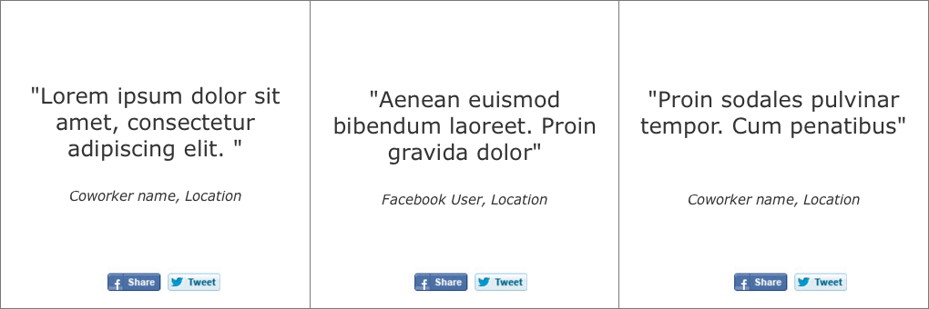
  - Campaign landing page - Phase 1b
    - User Interface
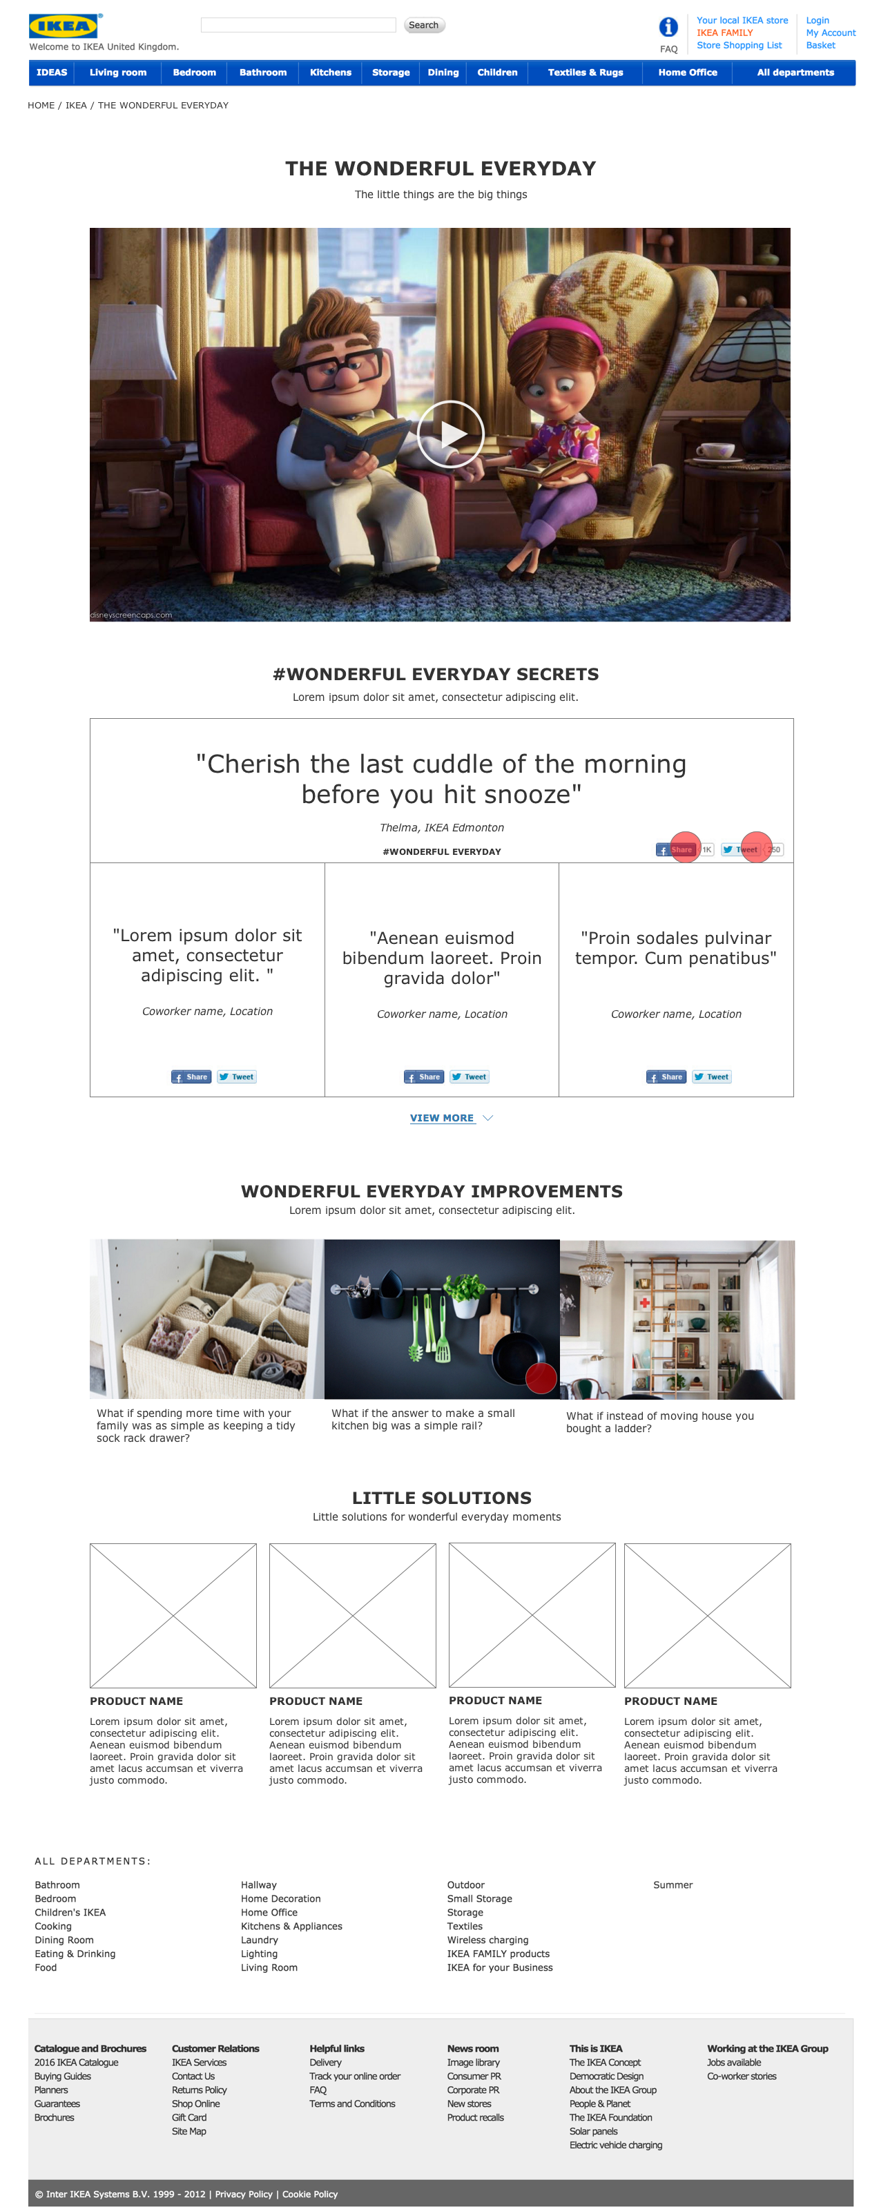
    - more secrets
      - State1
      - User Interface
  - Campaign landing page - Phase 2
    - User Interface
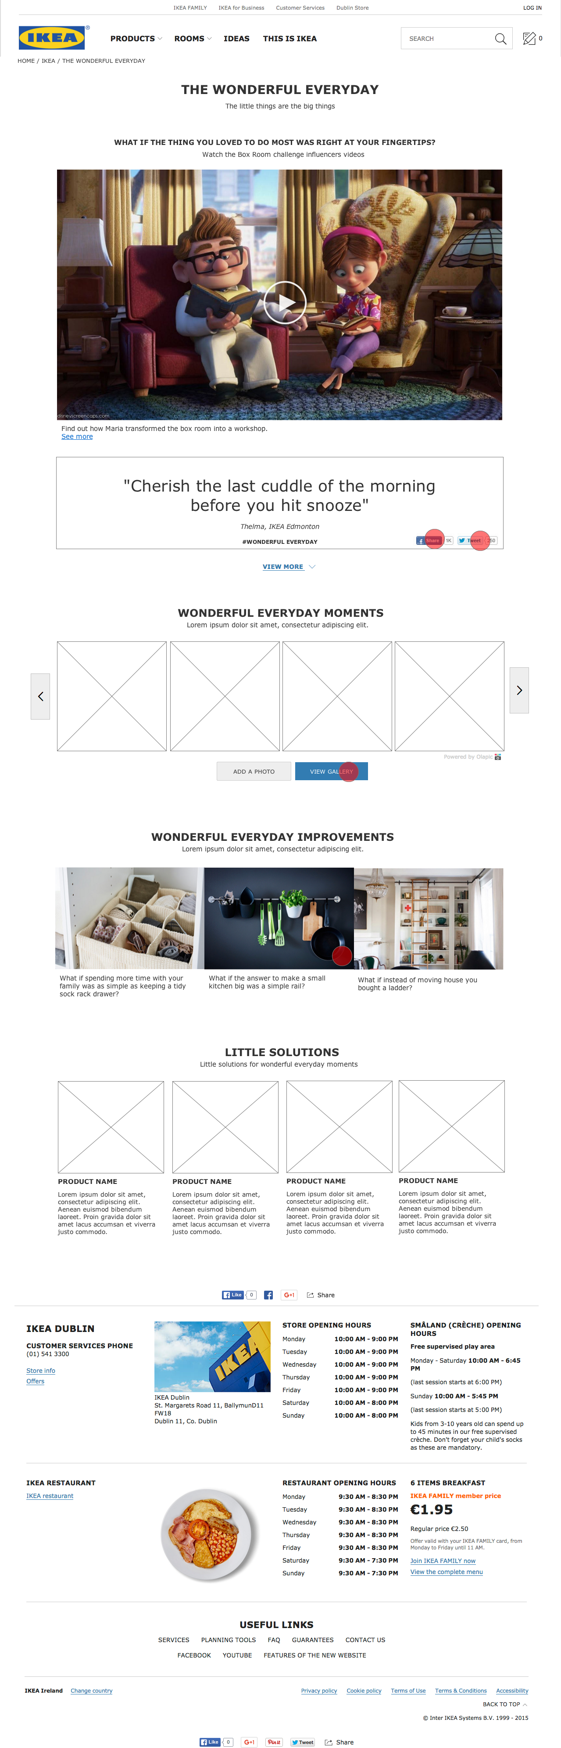
  - Campaign landing page - Phase 3
    - User Interface
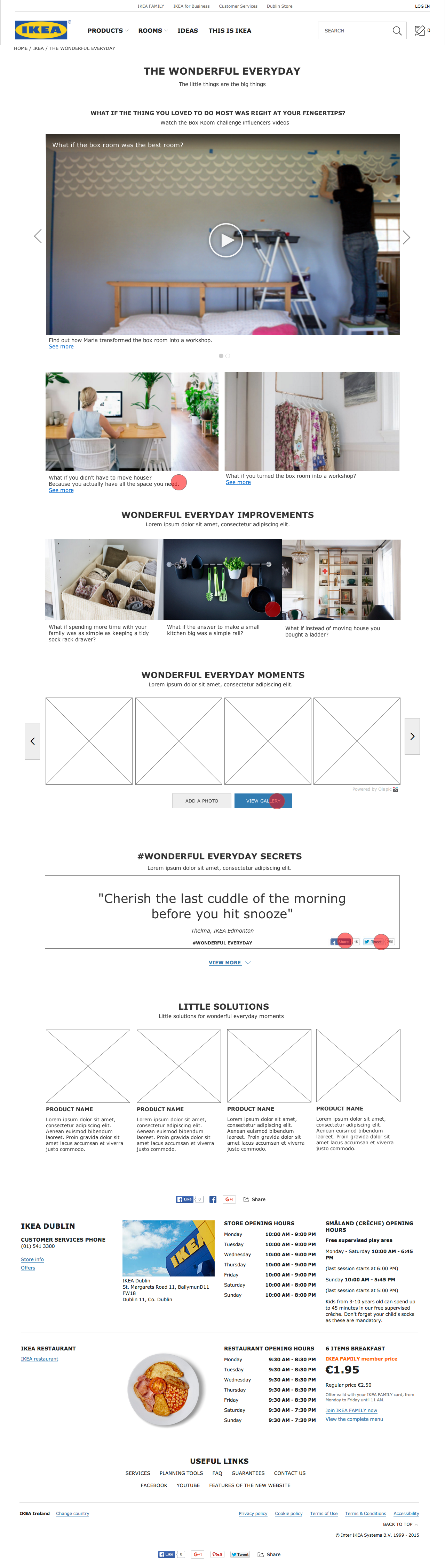
  - Social media sharing - Flow
    - User Interface
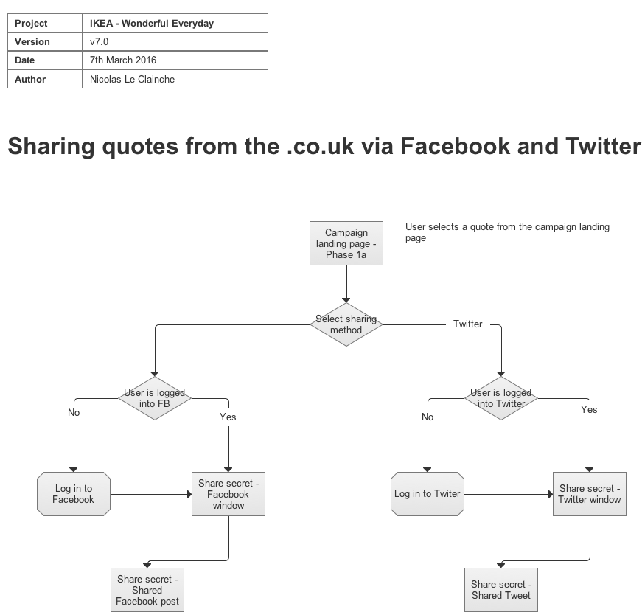
  - Share secret - Facebook window
    - User Interface
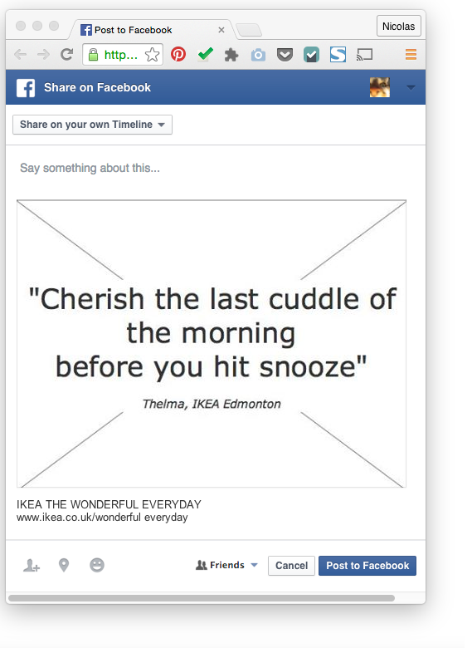
  - Share secret - Shared Facebook post
    - User Interface
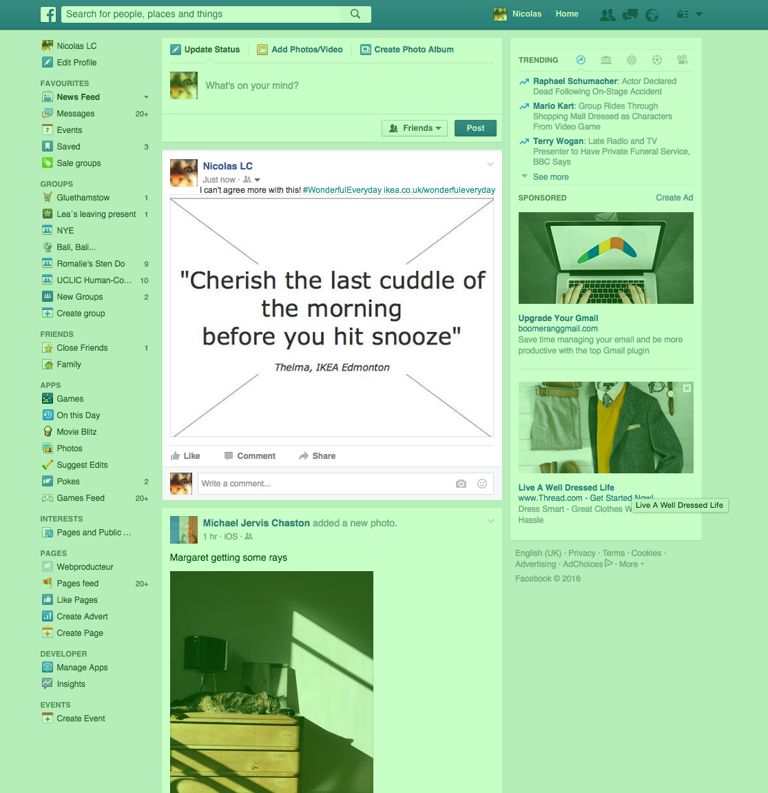
  - Share secret - Twitter window
    - User Interface
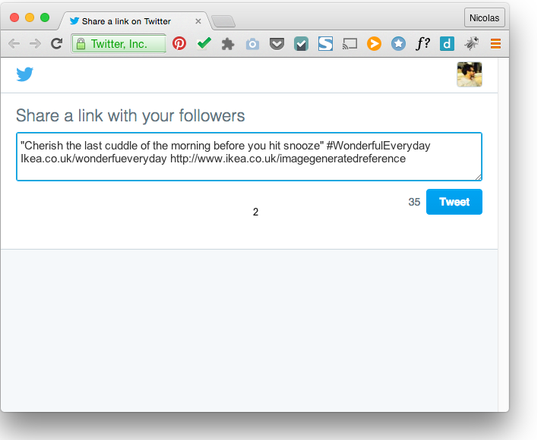
  - Share secret - Shared Tweet
    - User Interface
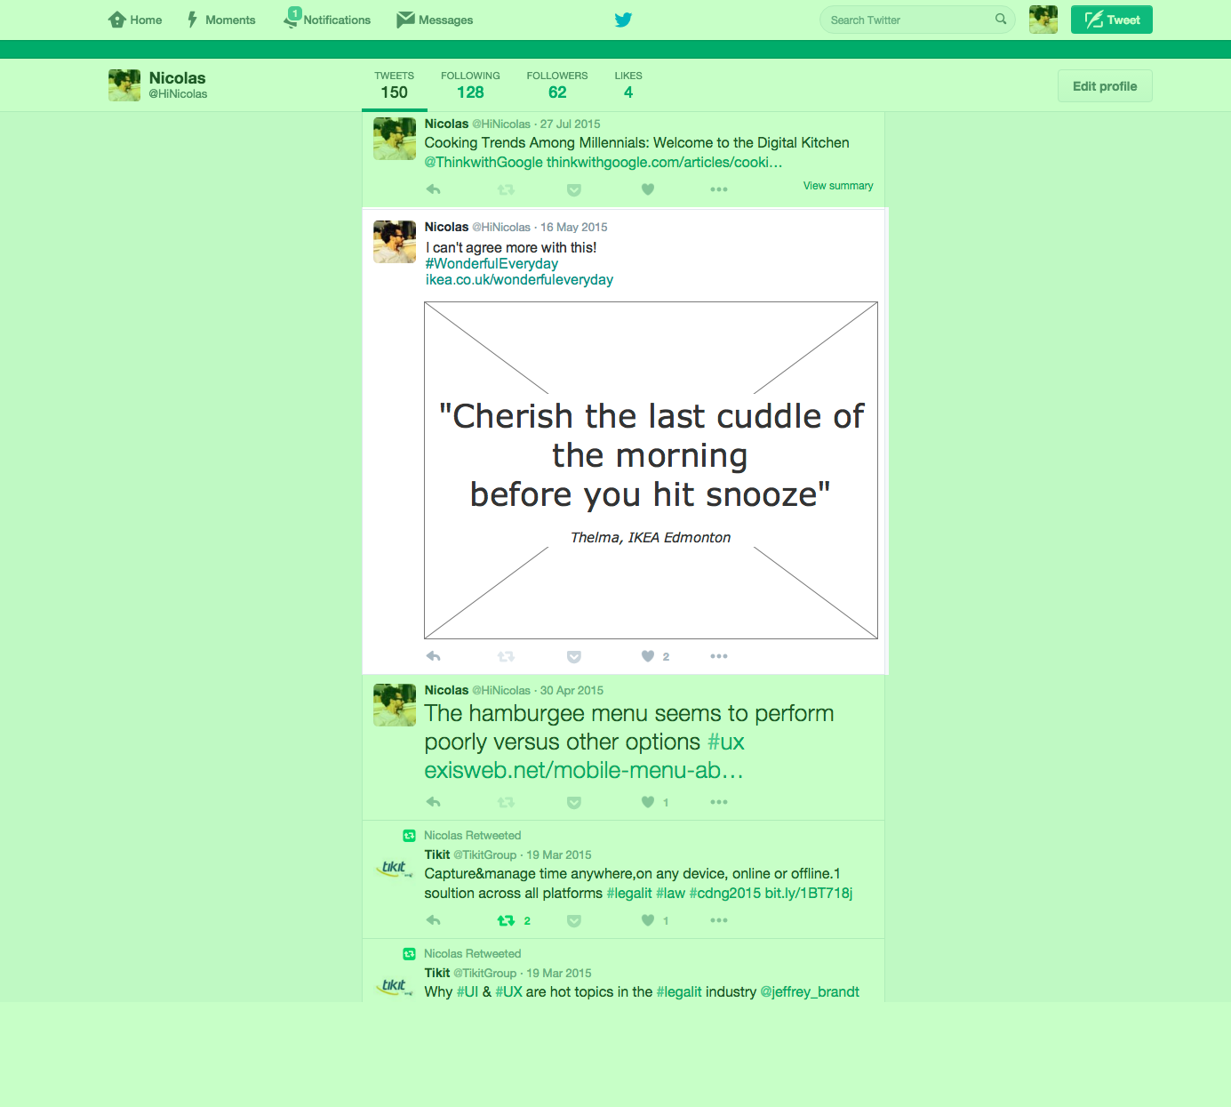
  - Ideas
    - User Interface
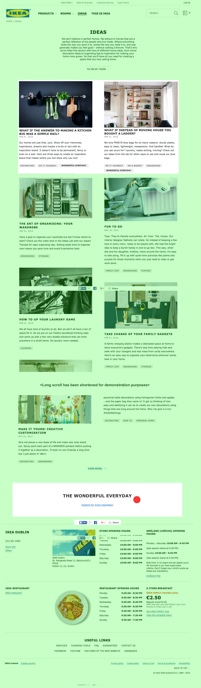
  - Ideas - Themes filtering w/mask
    - User Interface
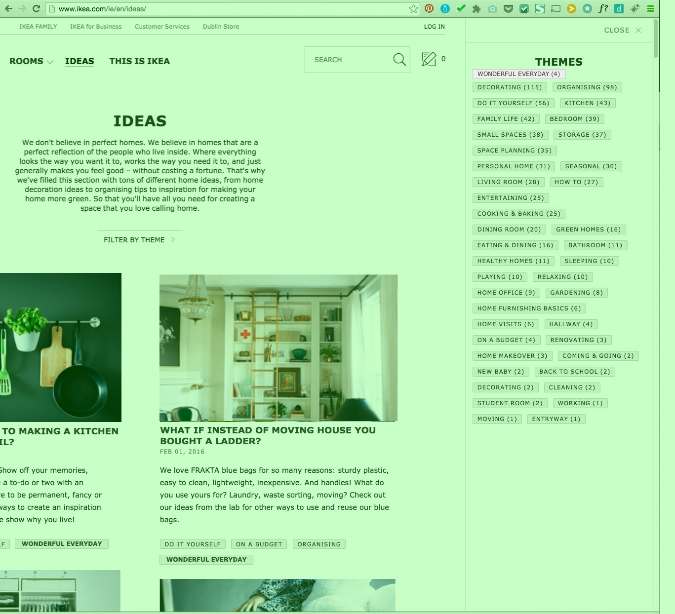
  - Ideas page - Wonderful everyday themed ideas cluster
    - User Interface
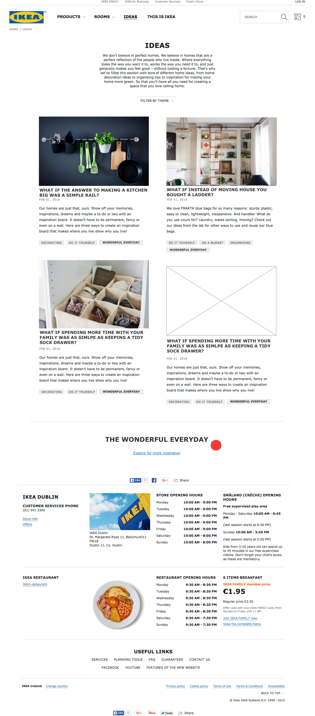
  - Idea - Item
    - User Interface
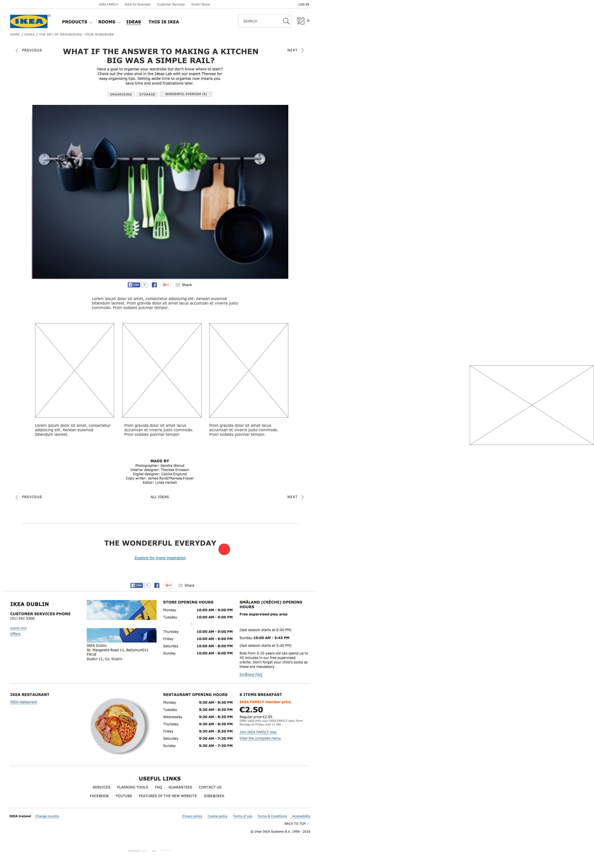
  - Room page
    - User Interface
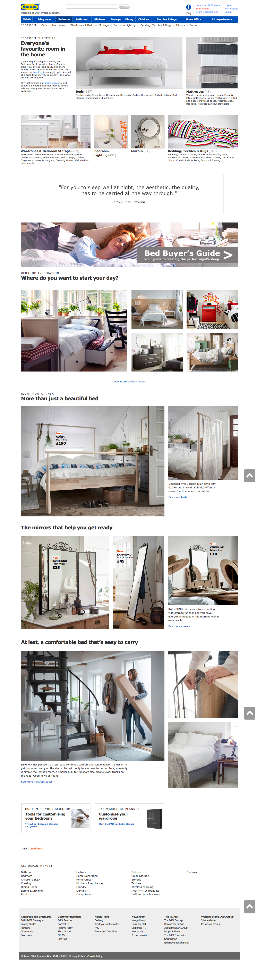
  - Product category
    - User Interface
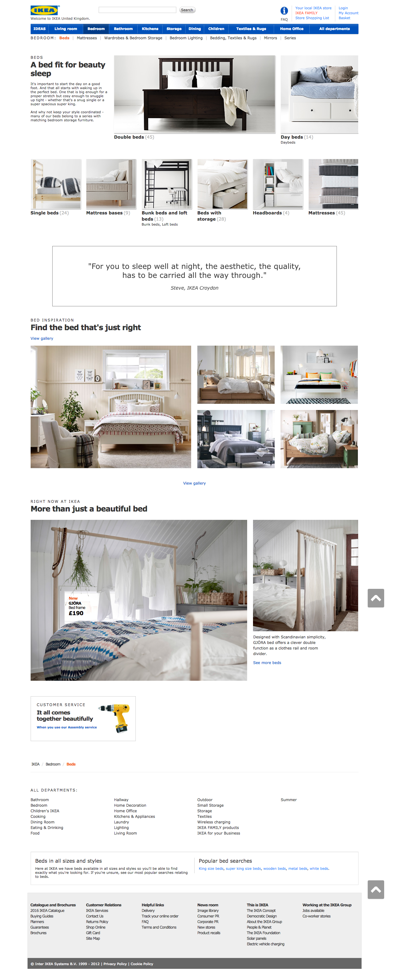
  - Sub-category
    - User Interface
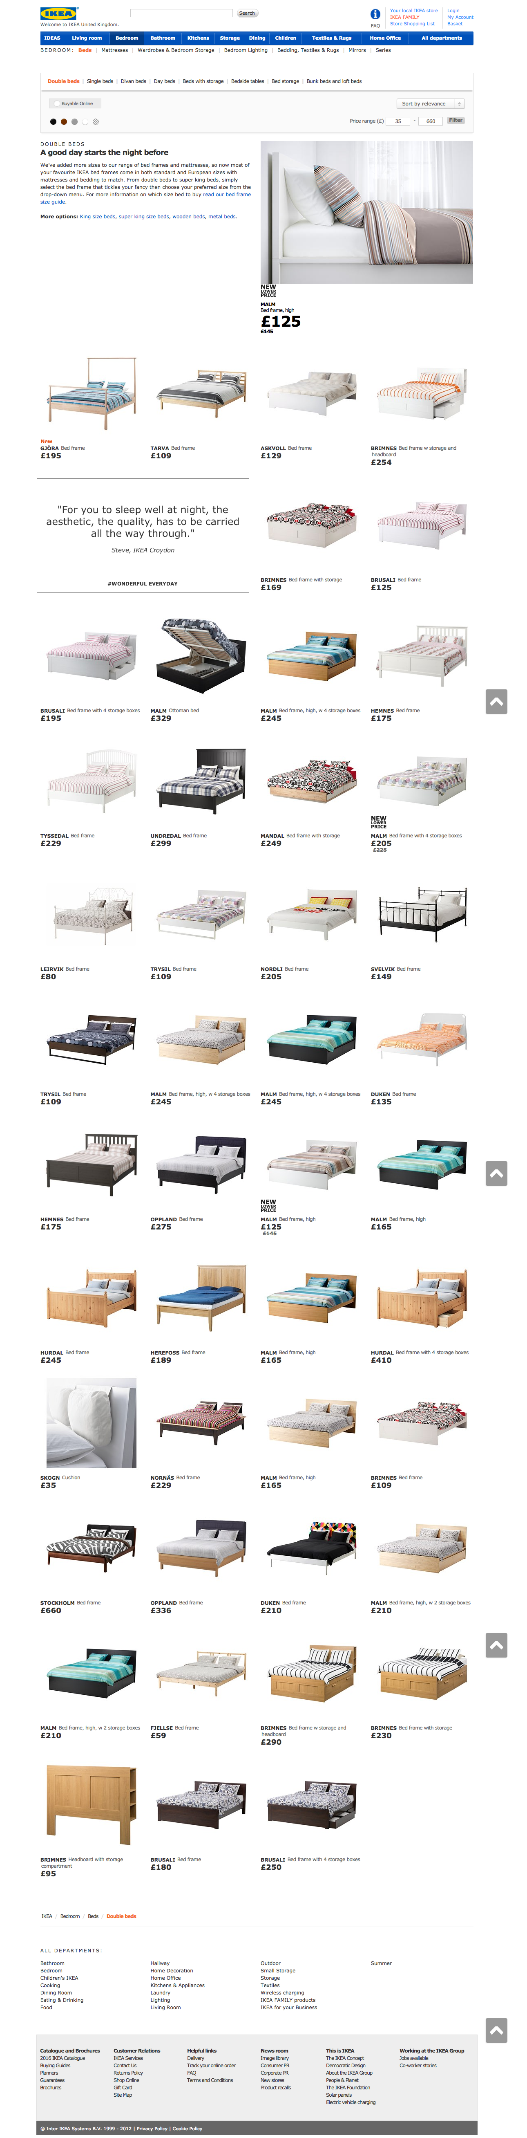
  - Product item - Option 1 (recommended)
    - User Interface
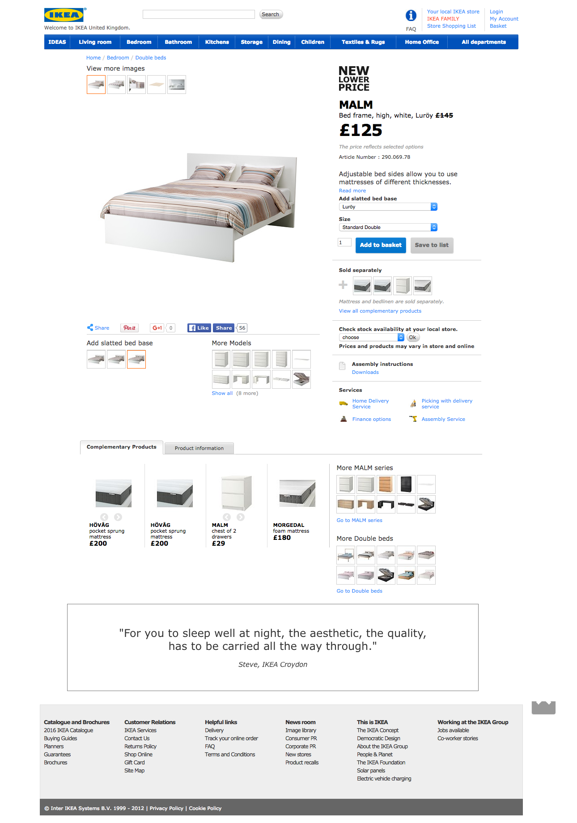
  - Product item - Option 2
    - User Interface
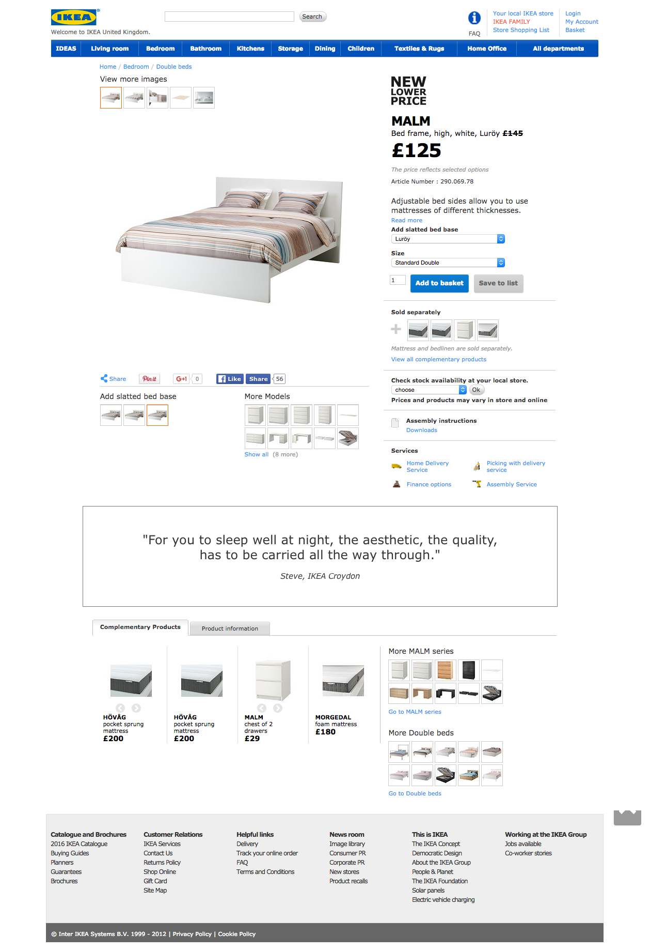
  - Product category
    - User Interface
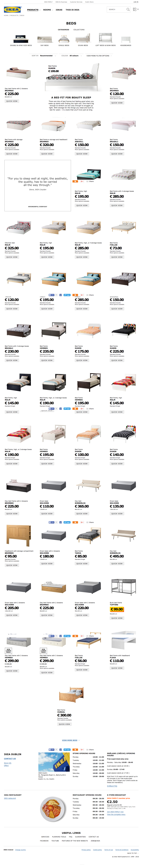
  - Sub-category
    - User Interface
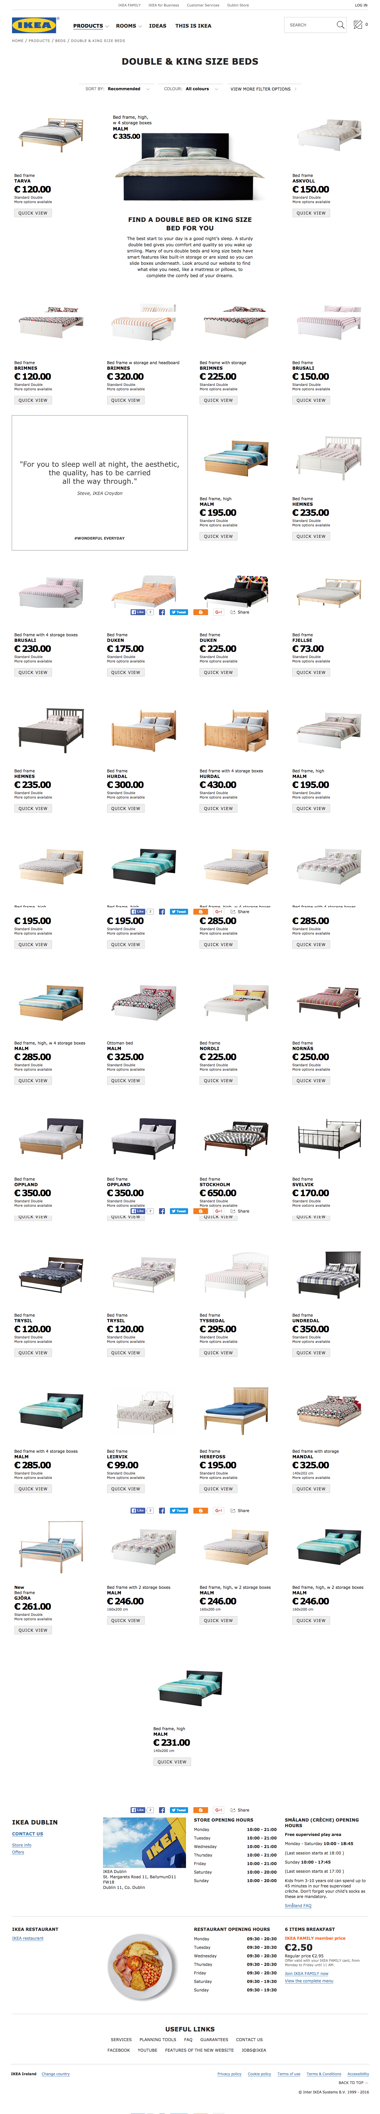
  - Product item (not recommended as this may break the flow of the page)
    - User Interface
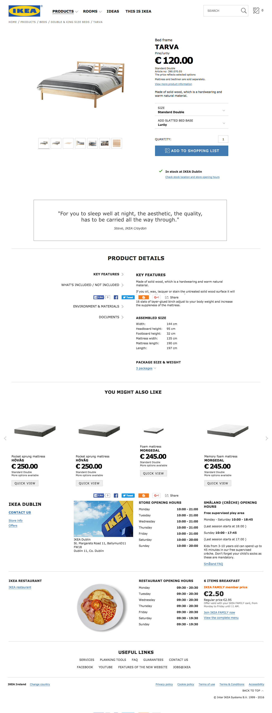
  - Box room challenge page (x3)
    - User Interface
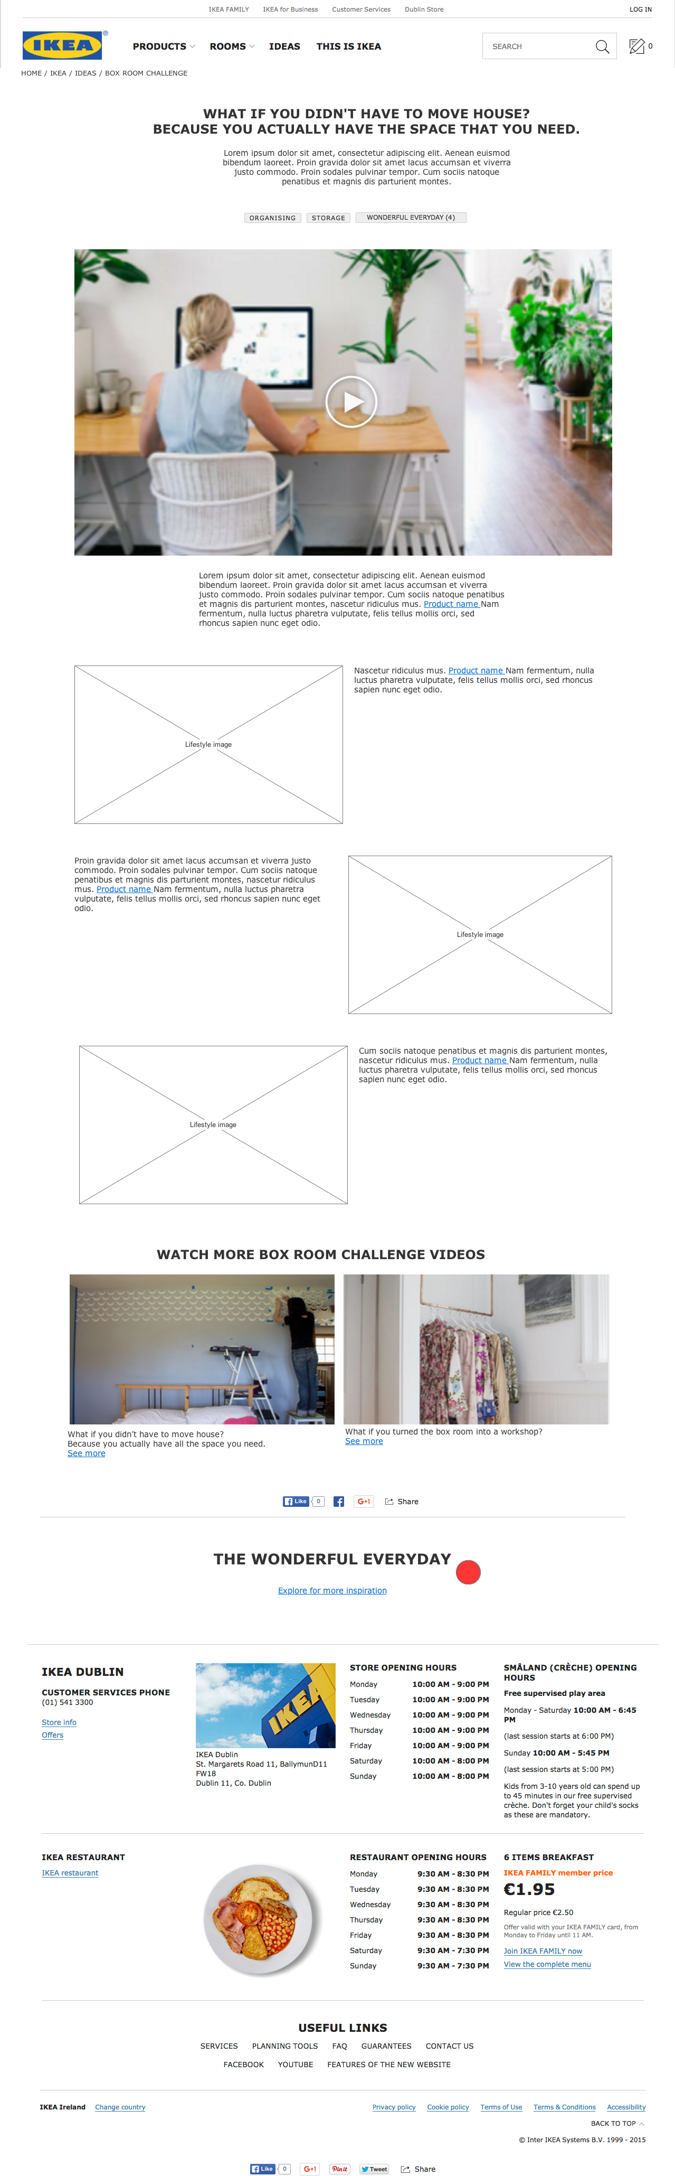
  - OLAPIC UGC Gallery
    - User Interface
