IKEA - The Joy of Storage
Campaign Hub – v1.0
03/11/15

Table of Contents
Structure 4
1.1.1. User Interface 4
1.2. Structure detailed 5
1.2.1. User Interface 5
1.3. Landing page v1.0 - With targeting - JOS.1 6
1.3.1. User Interface 6
1.4. Landing page - No targeting - JOS.1.2 - UK 7
1.4.1. User Interface 7
1.5. Landing page - JOS.1.1 - Mobile 8
1.5.1. User Interface 8
1.6. Landing page - No targeting - JOS.1.1 - IE 9
1.6.1. User Interface 9
1.7. Storage Solutions Finder - JOS.2 10
1.7.1. User Interface 10
1.8. Ideas aggregator - JOS.3 11
1.8.1. User Interface 11
1.9. Ideas aggregator - populated test 12
1.9.1. User Interface 12
1.10. UGC Gallery - JOS.4 13
1.10.1. User Interface 13
1.11. UGC - Olapic image view - JOS.5 14
1.11.1. User Interface 14
1.12. UGC Upload - JOS.6.1 15
1.12.1. User Interface 15
1.13. UGC Upload - JOS.6.2.a 16
1.13.1. User Interface 16
1.14. UGC Upload - JOS.6.2.b 17
1.14.1. User Interface 17
1.15. UGC Upload - JOS.6.2.c 18
1.15.1. User Interface 18
1.16. UGC Upload - JOS.6.2.d 19
1.16.1. User Interface 19

Structure
    - User Interface
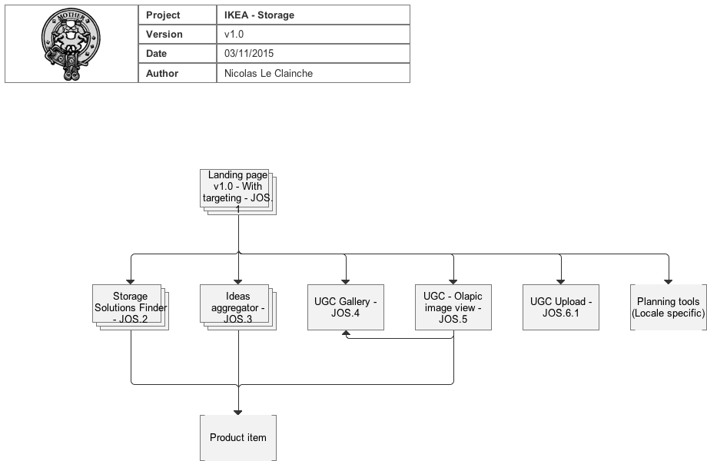
  - Structure detailed
    - User Interface
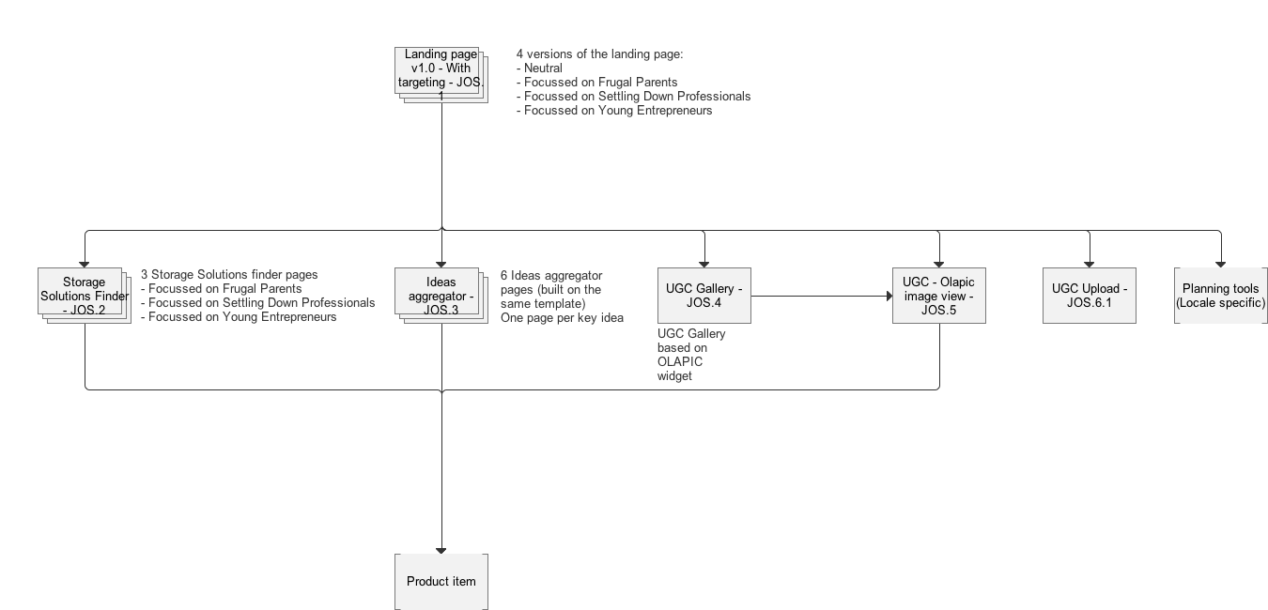
  - Landing page v1.0 - With targeting - JOS.1
    - User Interface
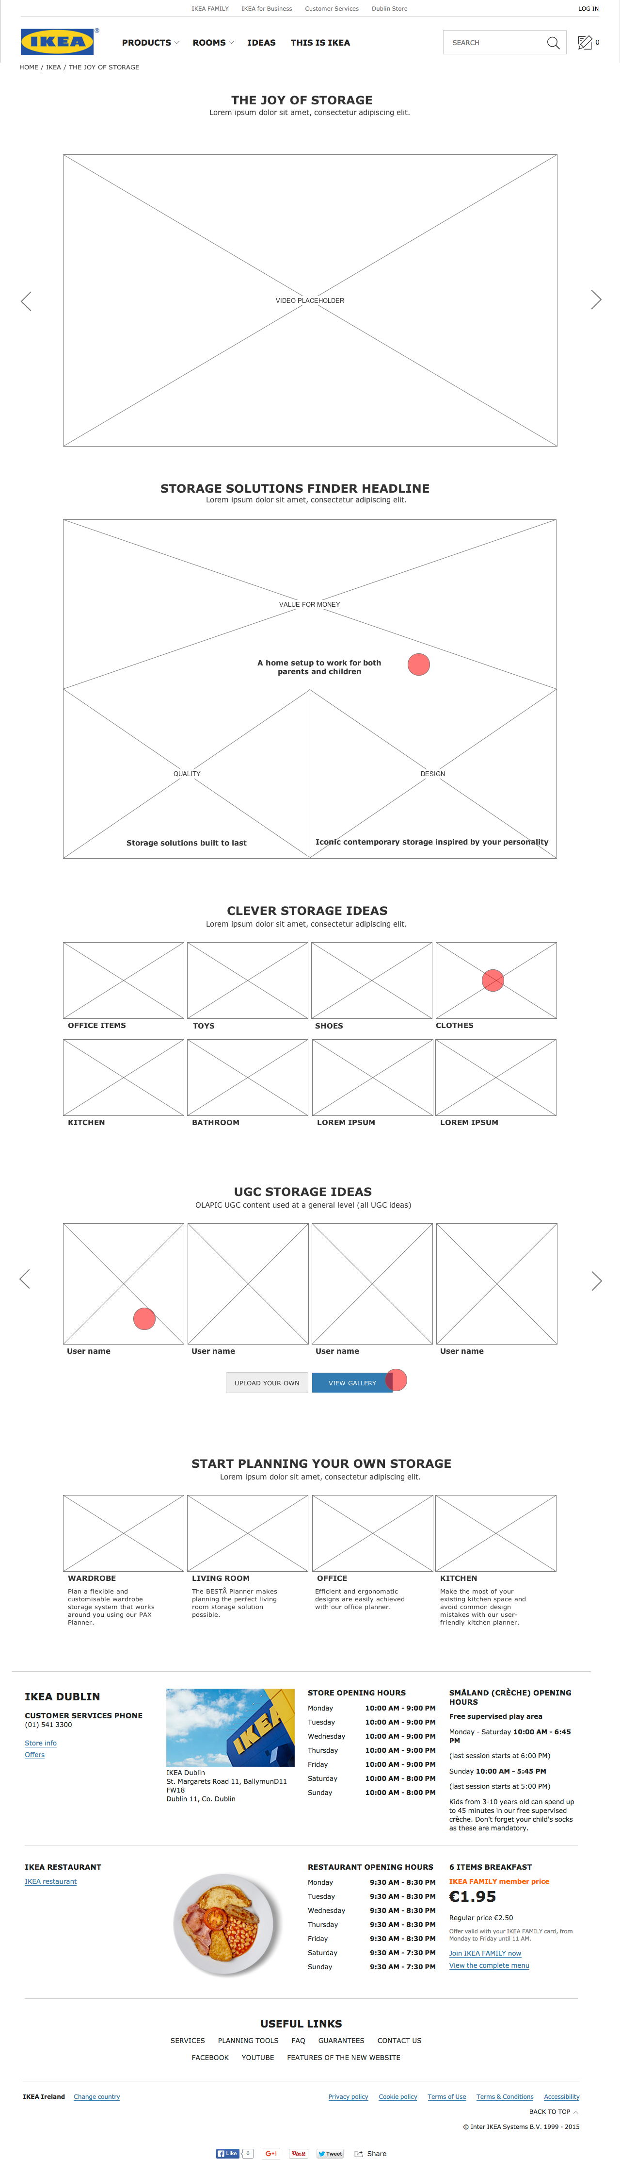
  - Landing page - No targeting - JOS.1.2 - UK
    - User Interface
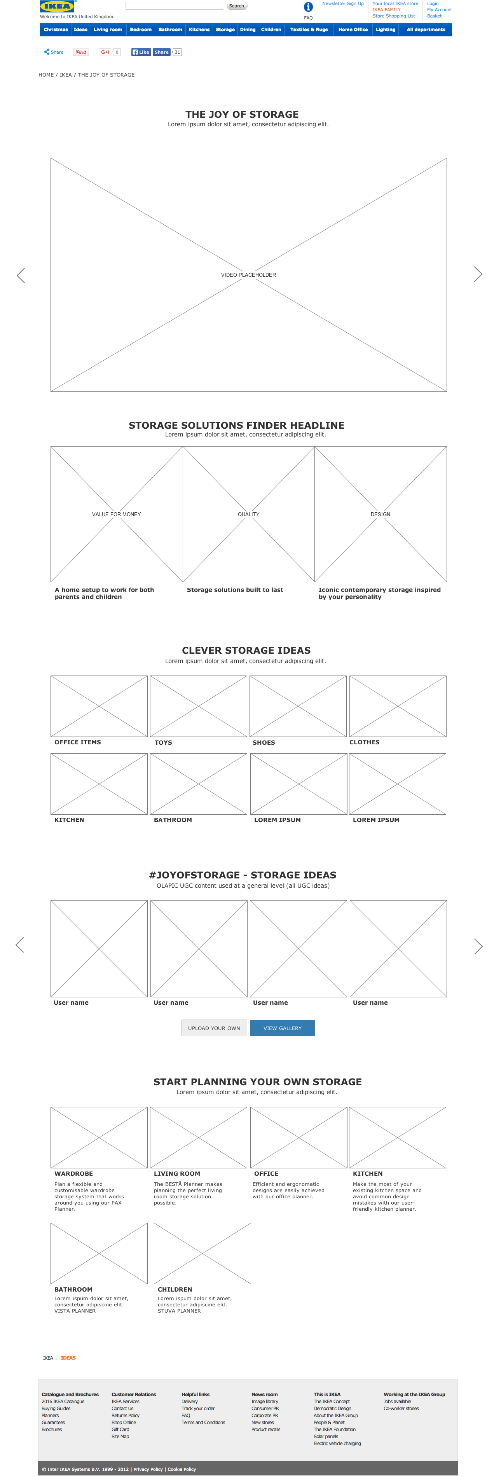
  - Landing page - JOS.1.1 - Mobile
    - User Interface
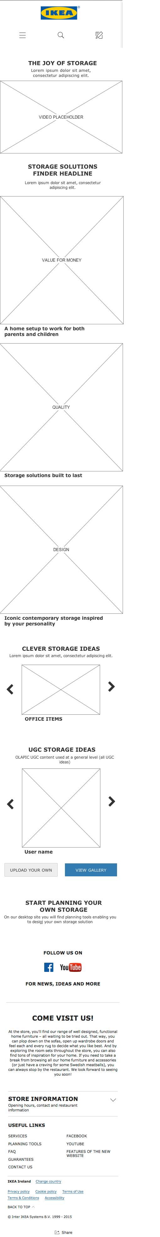
  - Landing page - No targeting - JOS.1.1 - IE
    - User Interface
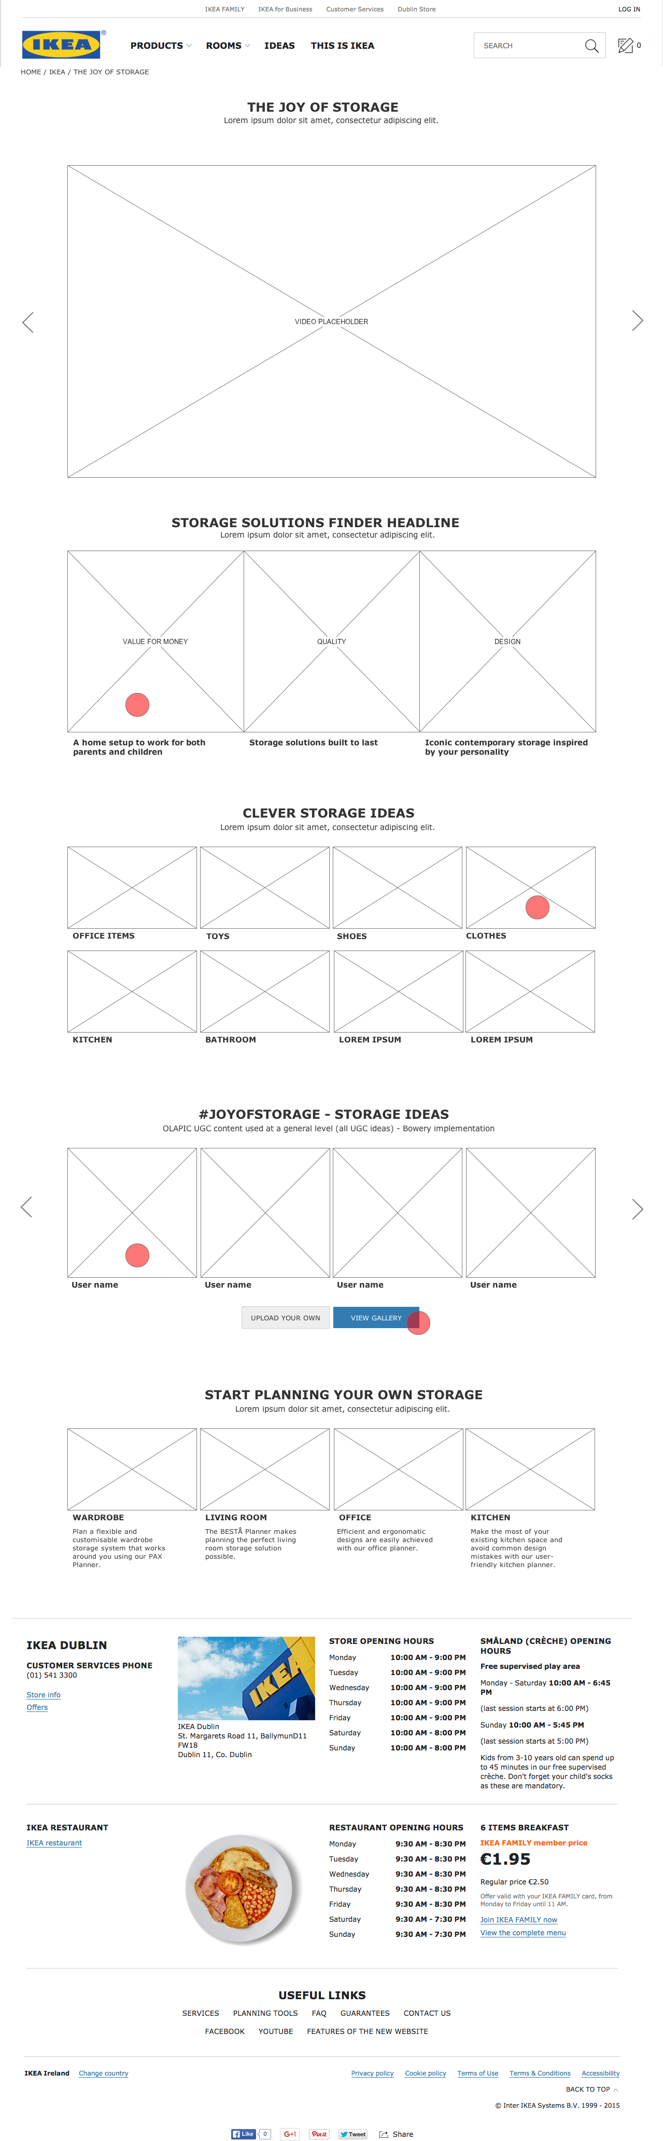
  - Storage Solutions Finder - JOS.2
    - User Interface
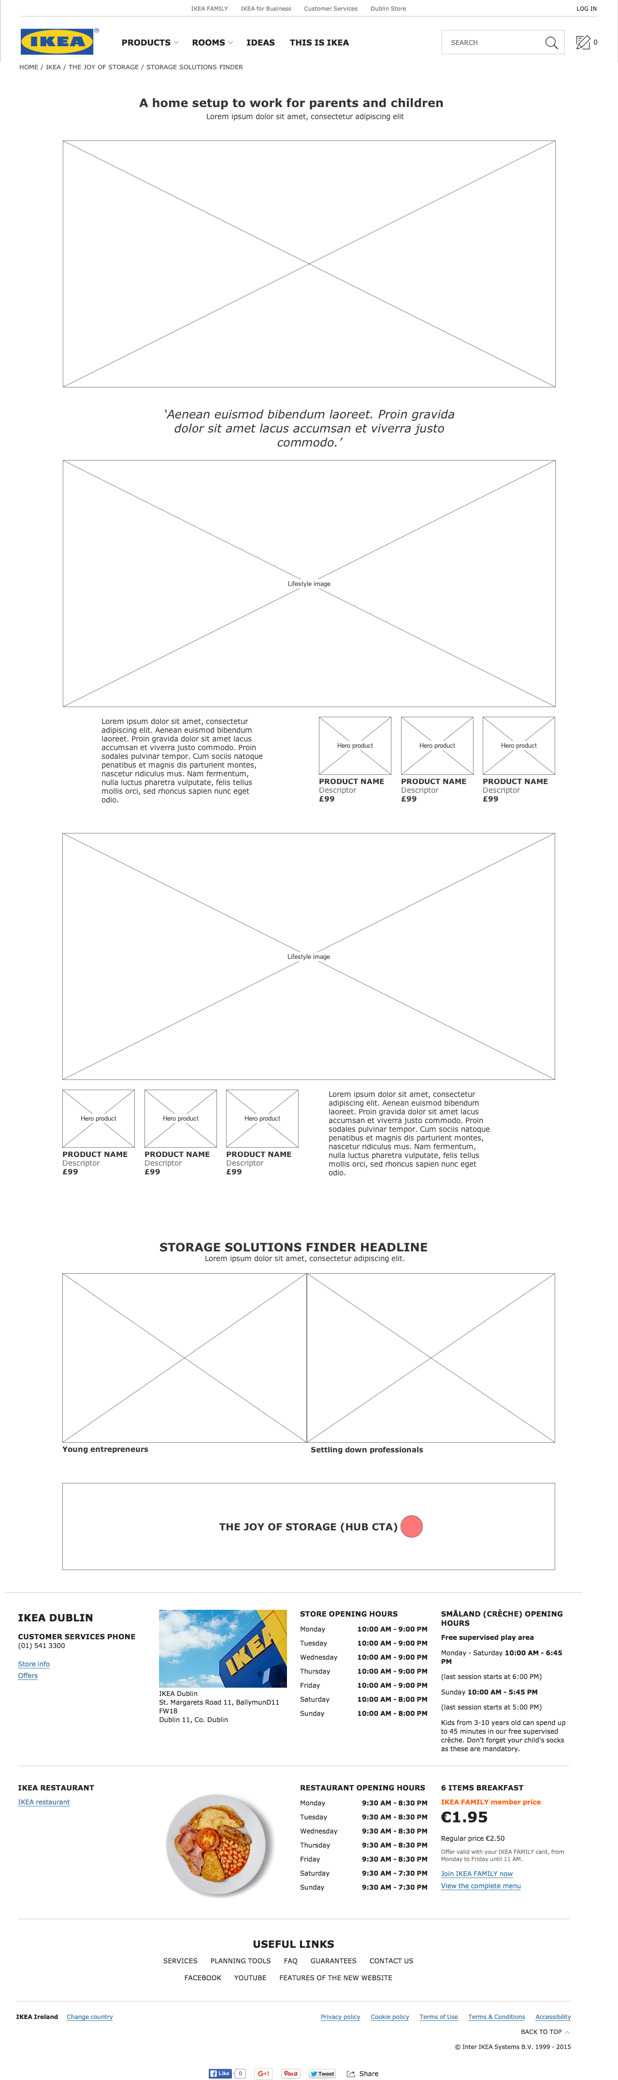
  - Ideas aggregator - JOS.3
    - User Interface
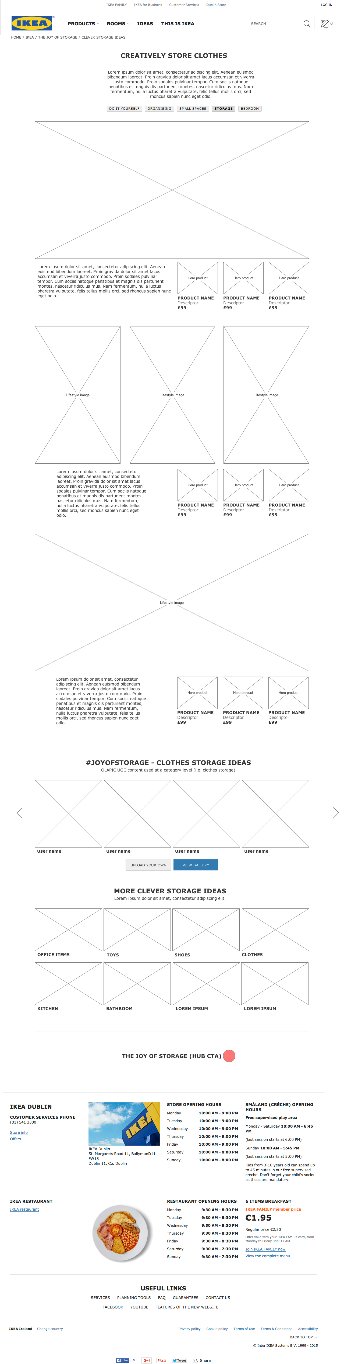
  - Ideas aggregator - populated test
    - User Interface
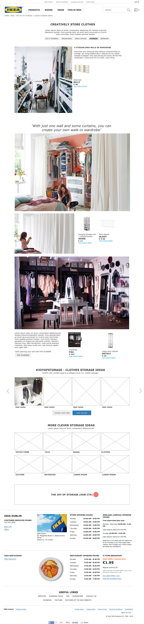
  - UGC Gallery - JOS.4
    - User Interface
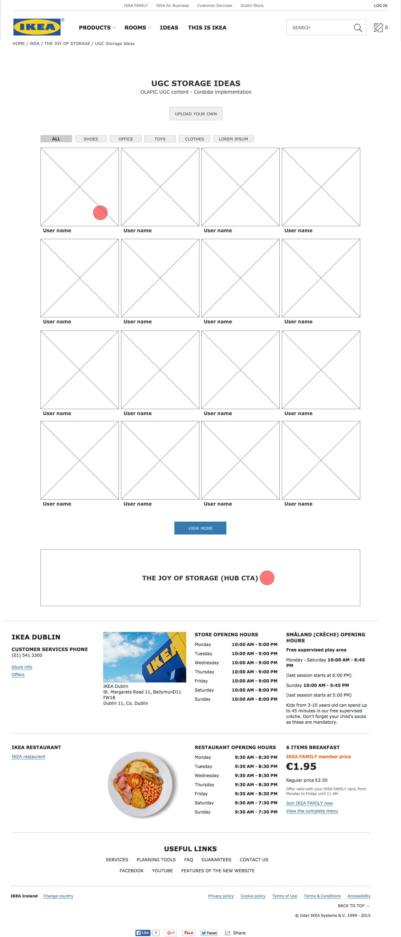

  - UGC - Olapic image view - JOS.5
    - User Interface
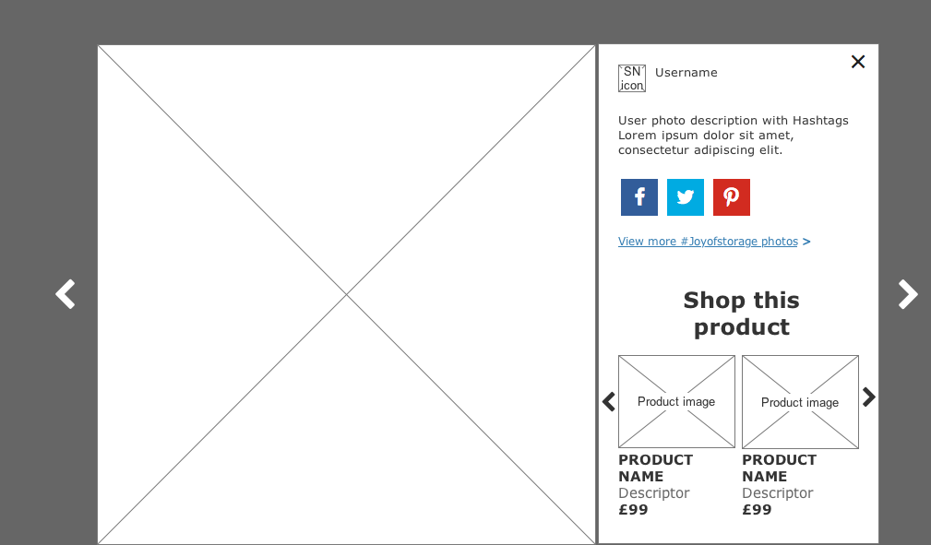
  - UGC Upload - JOS.6.1
    - User Interface
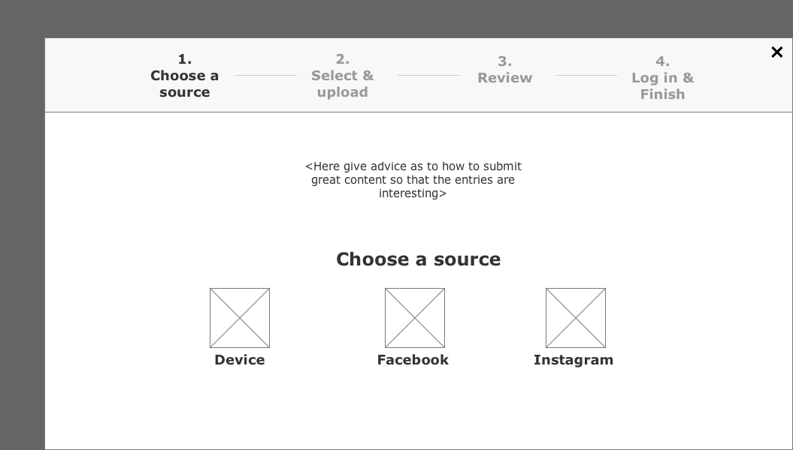
  - UGC Upload - JOS.6.2.a
    - User Interface
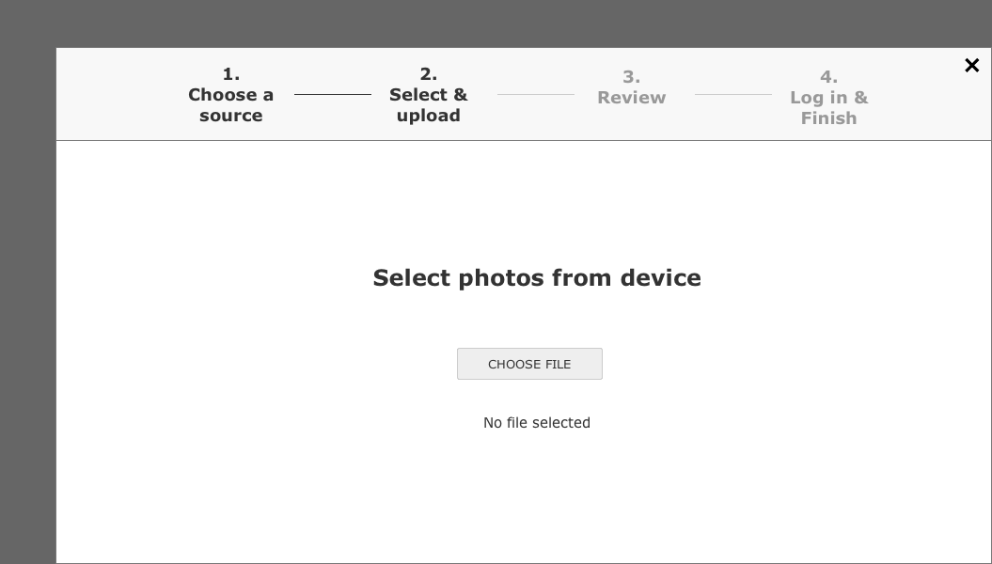
  - UGC Upload - JOS.6.2.b
    - User Interface
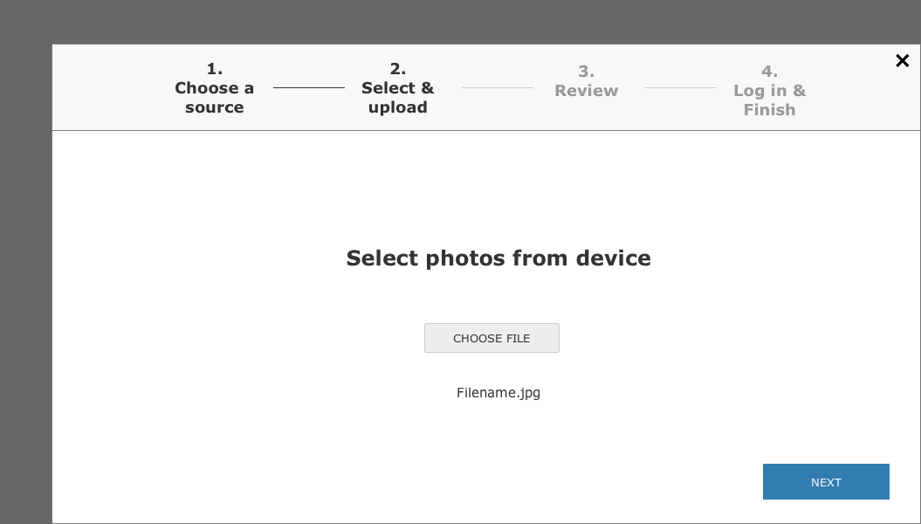
  - UGC Upload - JOS.6.2.c
    - User Interface
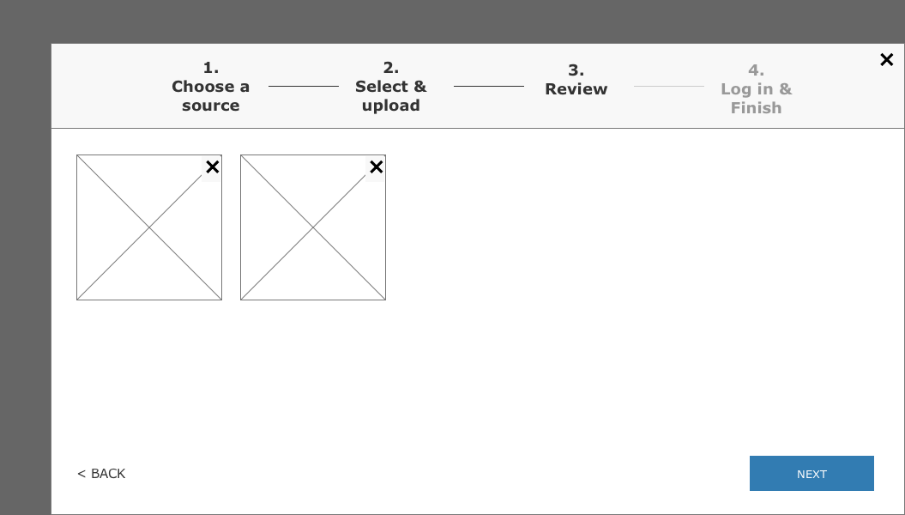
  - UGC Upload - JOS.6.2.d
    - User Interface
