Interactive recipes
Related products

Ref: | IKEA FOOD Campaign ‘16
Contact | nicolas@uxconsult.com
Version | 4th July ‘16 - v1.0

This document suggests a list of products related to each interactive recipe. This document presents the recipes in alphabetical order.

Cheesecake in a glass
Crispbread with dill, blue cheese and figs
Cinnamon Buns
Deviled eggs with smoked salmon
Fresh apple and elderflower spritz
Huevos rancheros con Veggie balls
Kale salad
Mustard glazed meatballs with kale chips and lingonberry chutney
Salmon Avocado Salad
Thin bread rolls with prosciutto and horseradish

Cheesecake in a glass
Product name | Image | UK link | IE Link
POKAL  Wine glass, clear glass | 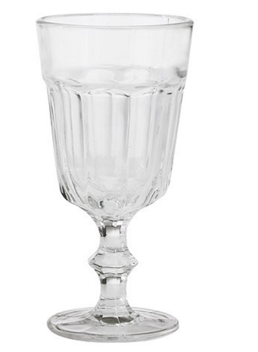 | http://www.ikea.com/gb/en/catalog/products/10215095/ | http://www.ikea.com/ie/en/products/tableware/glasses-cups-mugs/pokal-wine-glass-clear-glass-art-10215095/
KAKOR HAVREFLARN  Oat crisps | 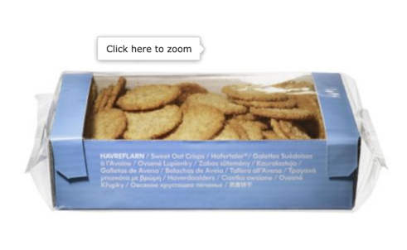 | http://www.ikea.com/gb/en/catalog/products/49650057/ | http://www.ikea.com/ie/en/products/food-beverages/pastries-desserts-cookies/kakor-havreflarn-oat-crisps-art-49650057/
SKALAD  Paring knife, grey | 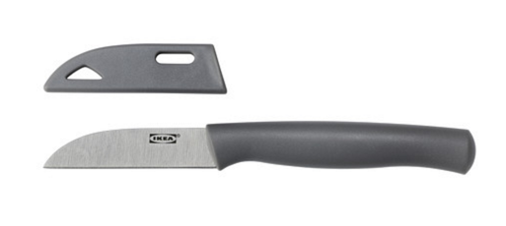 | http://www.ikea.com/gb/en/catalog/products/80256704/ | http://www.ikea.com/ie/en/products/cookware/knives-chopping-boards/skalad-paring-knife-grey-art-80256704/
APTITLIG  Chopping board, bamboo | 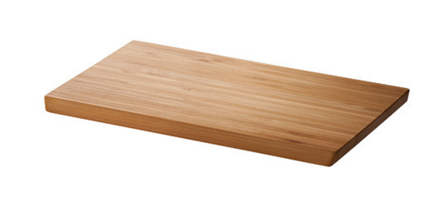 | http://www.ikea.com/gb/en/catalog/products/60233426/ | http://www.ikea.com/ie/en/products/cookware/knives-chopping-boards/aptitlig-chopping-board-bamboo-art-80233430/

Crispbread with dill, blue cheese and figs
Product name | Image | UK link | IE Link
KNÄCKEBRÖD DILL | 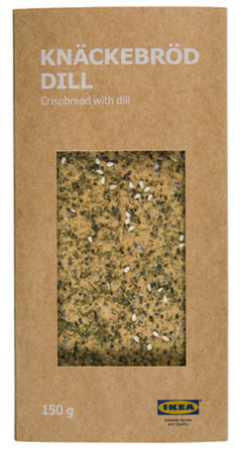 | http://www.ikea.com/gb/en/catalog/products/30264400/ | http://www.ikea.com/ie/en/products/food-beverages/bread-dairy/kn%C3%A4ckebr%C3%B6d-dill-crispbread-with-dill-art-30264400/
OST BLÅMÖGEL | 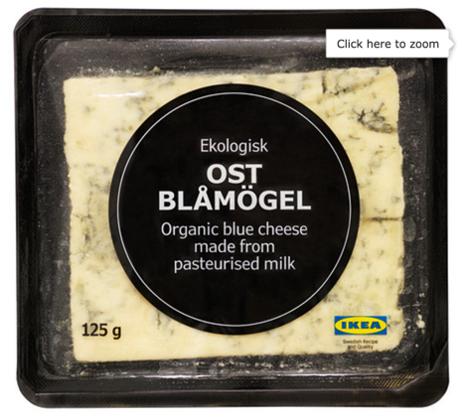 | http://www.ikea.com/gb/en/catalog/products/20271203/ | http://www.ikea.com/ie/en/products/food-beverages/bread-dairy/ost-bl%C3%A5m%C3%B6gel-blue-cheese-art-20271203/
PROPPMÄTT  Chopping board, beech | 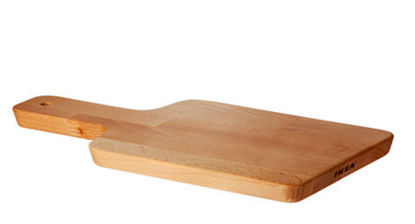 | http://www.ikea.com/gb/en/catalog/products/30233418/ | http://www.ikea.com/ie/en/products/cookware/knives-chopping-boards/proppm%C3%A4tt-chopping-board-beech-art-30233418/
VARDAGEN  Vegetable knife, dark grey | 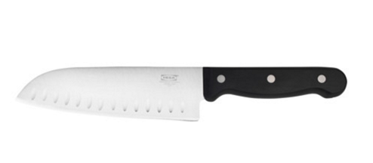 | http://www.ikea.com/gb/en/catalog/products/60294716/ | http://www.ikea.com/ie/en/products/cookware/knives-chopping-boards/vardagen-vegetable-knife-dark-grey-art-60294716/

Cinnamon Buns
Product name | Image | UK link | IE Link
LÄMPLIG  Chopping board, bamboo | 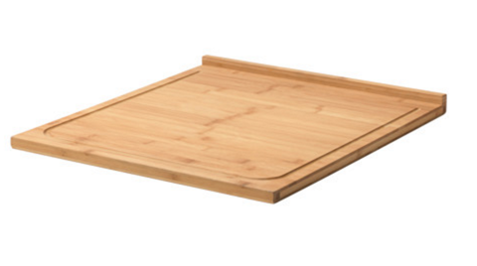 | http://www.ikea.com/gb/en/catalog/products/00309829/ | http://www.ikea.com/ie/en/products/cookware/knives-chopping-boards/l%C3%A4mplig-chopping-board-bamboo-art-00309829/
JÄMFÖRLIG  Hand-held whisk, black, red | 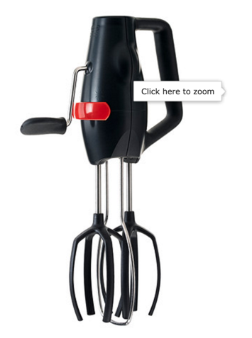 | http://www.ikea.com/gb/en/catalog/products/10233669/ | http://www.ikea.com/ie/en/products/cookware/kitchen-utensils/j%C3%A4mf%C3%B6rlig-hand-held-whisk-black-red-art-10233669/
ALLEHANDA  Mixing bowl with lid, green | 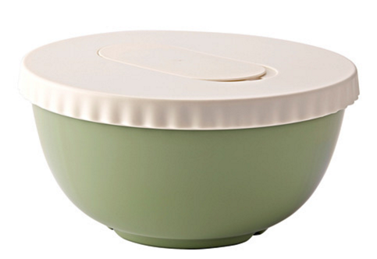 | http://www.ikea.com/gb/en/catalog/products/50233549/ | http://www.ikea.com/ie/en/products/cookware/mixing-measuring-tools/allehanda-mixing-bowl-with-lid-green-art-50233549/
VARDAGEN  Saucepan with lid | 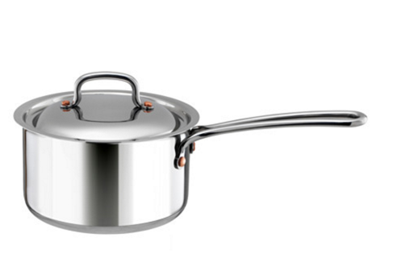 | http://www.ikea.com/gb/en/catalog/products/50305715/ | http://www.ikea.com/ie/en/products/cookware/pots-pans/vardagen-saucepan-with-lid-art-50305715/

Deviled eggs with smoked salmon
LAX KALLRÖKT  Smoked salmon, frozen | 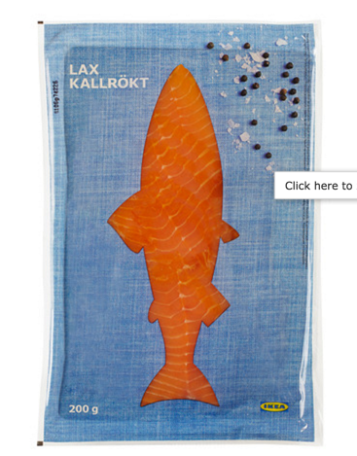 | http://www.ikea.com/gb/en/catalog/products/60224851/ | http://www.ikea.com/ie/en/products/food-beverages/fish-seafood/lax-kallr%C3%B6kt-smoked-salmon-frozen-art-60224851/
VISPAD  Mixing bowl, set of 2, white | 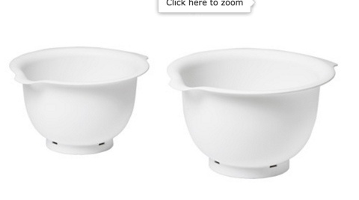 | http://www.ikea.com/gb/en/catalog/products/90257519/ | http://www.ikea.com/ie/en/products/cookware/mixing-measuring-tools/vispad-mixing-bowl-set-of-2-white-art-90257519/
FÄRGRIK  Plate, white, stoneware | 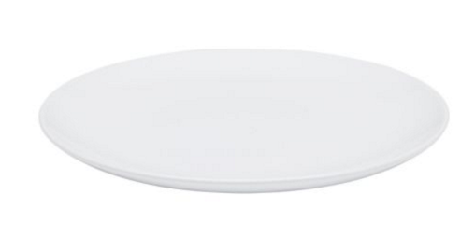 | http://www.ikea.com/gb/en/catalog/products/20131670/ | http://www.ikea.com/ie/en/products/tableware/dinnerware/f%C3%A4rgrik-plate-white-stoneware-art-20131670/
KONCIS  Balloon whisk, stainless steel | 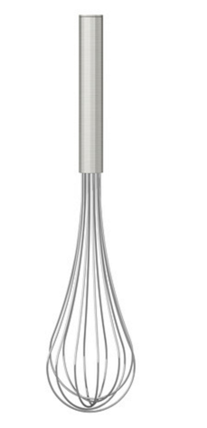 | http://www.ikea.com/gb/en/catalog/products/10225952/ | http://www.ikea.com/ie/en/products/cookware/kitchen-utensils/koncis-balloon-whisk-stainless-steel-art-10225952/

Fresh apple and elderflower spritz
DRYCK FLÄDER  Elderflower syrup | 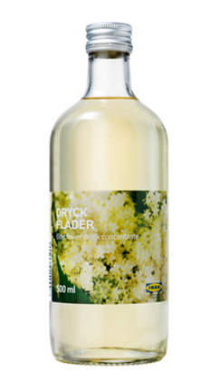 | http://www.ikea.com/gb/en/catalog/products/40296014/ | http://www.ikea.com/ie/en/products/food-beverages/beverages/dryck-fl%C3%A4der-elderflower-syrup-art-40296014/
FRASERA  Whiskey glass | 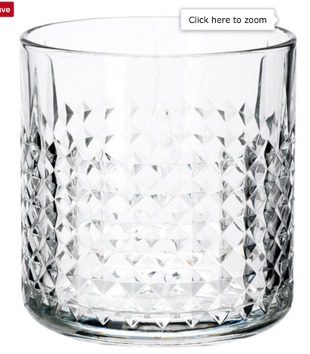 | http://www.ikea.com/gb/en/catalog/products/00208788/ | http://www.ikea.com/ie/en/products/tableware/glasses-cups-mugs/frasera-whiskey-glass-art-00208788/
SOMMAR 2016  Drinking straw, assorted colours |  | http://www.ikea.com/gb/en/catalog/products/20131670/ | http://www.ikea.com/ie/en/products/decoration/paper/sommar-2016-drinking-straw-assorted-colours-art-20311242/
PLASTIS  Ice cube tray, green/pink, turquoise | 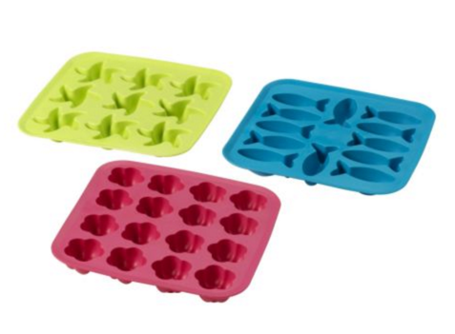 | http://www.ikea.com/gb/en/catalog/products/60138113/ | http://www.ikea.com/ie/en/products/cookware/kitchen-utensils/plastis-ice-cube-tray-green-pink-turquoise-art-60138113/

Huevos rancheros con Veggie balls
GRÖNSAKSBULLAR  Vegetable balls, frozen | 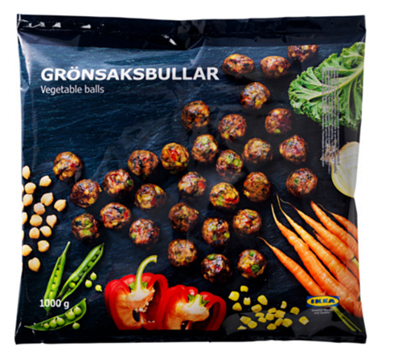 | http://www.ikea.com/gb/en/catalog/products/90309660/ | http://www.ikea.com/ie/en/products/food-beverages/vegetables-side-dishes/gr%C3%B6nsaksbullar-vegetable-balls-frozen-art-90309660/
SKÄNKA  Sauté pan with lid, grey | 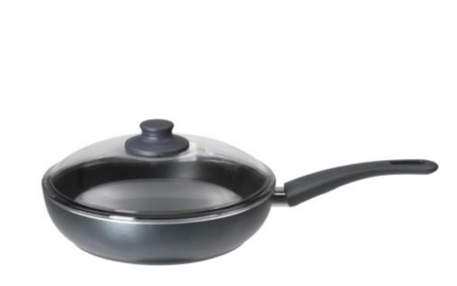 | http://www.ikea.com/gb/en/catalog/products/80129462/ | http://www.ikea.com/ie/en/products/cookware/frying-pans-woks/sk%C3%A4nka-saut%C3%A9-pan-with-lid-grey-art-80129462/
IKEA 365+ HJÄLTE  Turner, stainless steel, black | 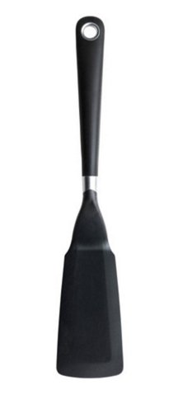 | http://www.ikea.com/gb/en/catalog/products/00149459/ | http://www.ikea.com/ie/en/products/cookware/kitchen-utensils/ikea-365-hj%C3%A4lte-turner-stainless-steel-black-art-00149459/
MAGASIN  Chopping board, set of 2, rubberwood | 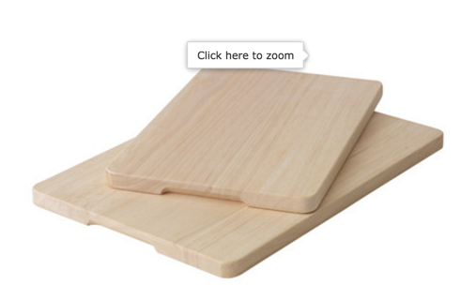 | http://www.ikea.com/gb/en/catalog/products/50228618/ | http://www.ikea.com/ie/en/products/cookware/knives-chopping-boards/magasin-chopping-board-set-of-2-rubberwood-art-50228618/

Kale salad
UTBUD  Serving bowl, off-white, green | 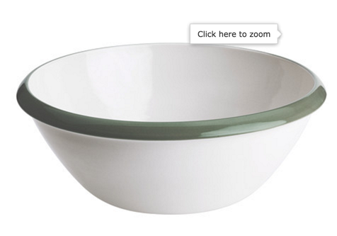 | http://www.ikea.com/gb/en/catalog/products/80258717/ | http://www.ikea.com/ie/en/products/tableware/serveware/utbud-serving-bowl-off-white-green-art-80258717/
KAVALKAD  Frying pan, set of 2, black | 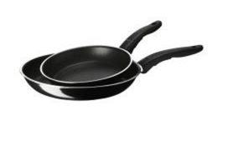 | http://www.ikea.com/gb/en/catalog/products/40139321/ | http://www.ikea.com/ie/en/products/cookware/frying-pans-woks/kavalkad-frying-pan-set-of-2-black-art-40139321/
SPECIELL  Turner, black | 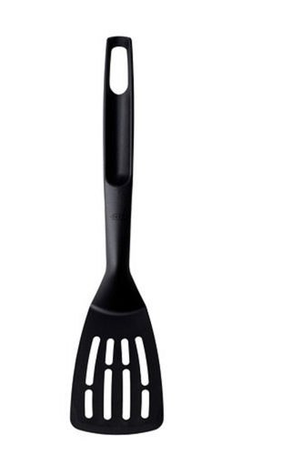 | http://www.ikea.com/gb/en/catalog/products/30238982/ | http://www.ikea.com/ie/en/products/cookware/kitchen-utensils/speciell-turner-black-art-30238982/
KAVALKAD  Saucepan, set of 3, black | 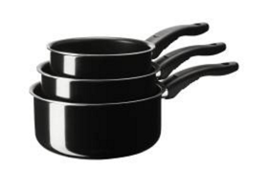 | http://www.ikea.com/gb/en/catalog/products/20139322/ | http://www.ikea.com/ie/en/products/cookware/pots-pans/kavalkad-saucepan-set-of-3-black-art-20139322/

Mustard glazed meatballs with kale chips and lingonberry chutney

SYLT LINGON  Lingonberry jam | 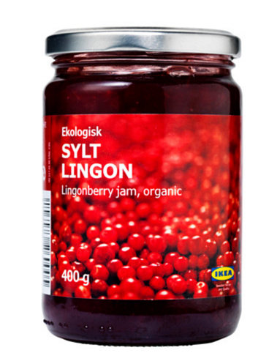 | http://www.ikea.com/gb/en/catalog/products/10308626/ | NOT AVAILABLE IN IE.  Use this serving dish as a replacement  http://www.ikea.com/ie/en/products/cookware/ovenware/mixtur-oven-serving-dish-clear-glass-art-80058761/
KÖTTBULLAR  Meatballs, frozen | 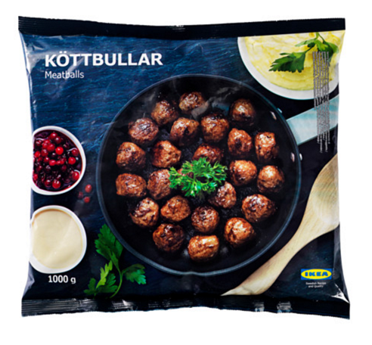 | http://www.ikea.com/gb/en/catalog/products/70028680/ | http://www.ikea.com/ie/en/products/food-beverages/meat/k%C3%B6ttbullar-meatballs-frozen-art-70028680/
DRÖMMAR  Baking tin, red | 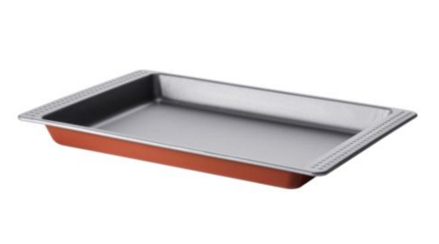 | http://www.ikea.com/gb/en/catalog/products/00133043/ | http://www.ikea.com/ie/en/products/cookware/bakeware/dr%C3%B6mmar-baking-tin-red-art-00133043/
TOKIG  Salad spinner, white | 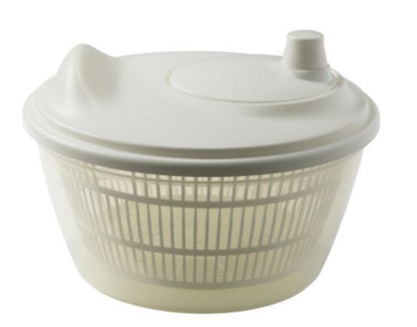 | http://www.ikea.com/gb/en/catalog/products/60148678/ | http://www.ikea.com/ie/en/products/cookware/mixing-measuring-tools/tokig-salad-spinner-white-art-60148678/

Salmon Avocado Salad
LAX FILÉ  Salmon fillet, frozen | 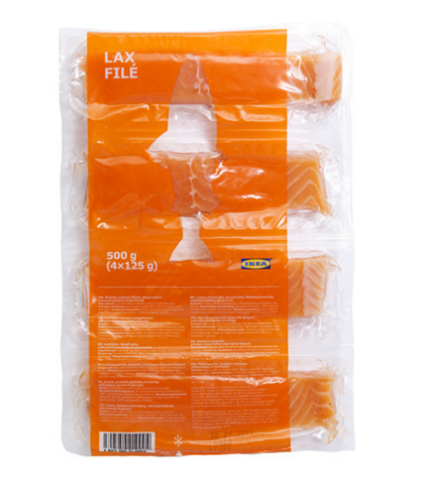 | http://www.ikea.com/gb/en/catalog/products/50225021/ | http://www.ikea.com/ie/en/products/food-beverages/fish-seafood/lax-fil%C3%A9-salmon-fillet-frozen-art-50225021/
GRILLA  Grill pan, black | 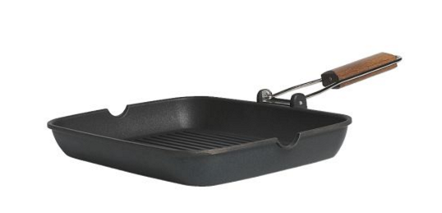 | http://www.ikea.com/gb/en/catalog/products/50055085/ | http://www.ikea.com/ie/en/products/cookware/frying-pans-woks/grilla-grill-pan-black-art-50055085/
IKEA 365+ HJÄLTE  Turner, stainless steel, black | 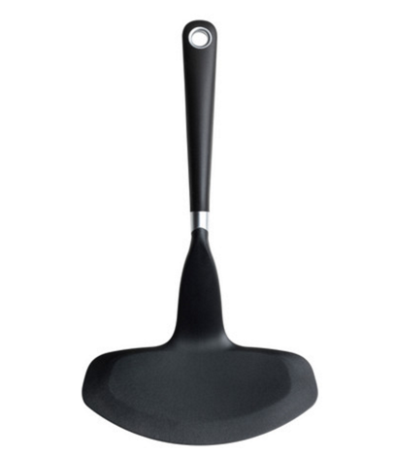 | http://www.ikea.com/gb/en/catalog/products/20149458/ | http://www.ikea.com/ie/en/products/cookware/kitchen-utensils/ikea-365-hj%C3%A4lte-turner-stainless-steel-black-art-20149458/
FÖRBLUFFAD  6-piece cookware set, golden-brown | 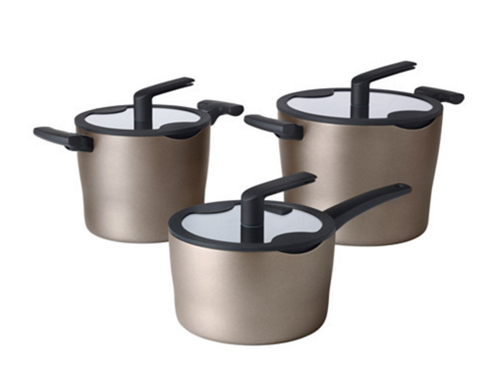 | http://www.ikea.com/gb/en/catalog/products/50310321/ | http://www.ikea.com/ie/en/products/cookware/pots-pans/f%C3%B6rbluffad-6-piece-cookware-set-golden-brown-art-50310321/

Thin bread rolls with prosciutto and horseradish
GARNERA  Serving stand, two tiers, white | 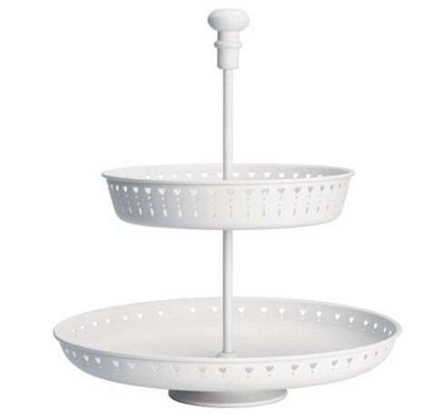 | http://www.ikea.com/gb/en/catalog/products/10258768/ | http://www.ikea.com/ie/en/products/tableware/serveware/garnera-serving-stand-two-tiers-white-art-10258768/
BRÖD TUNNBRÖD  Soft thin bread, frozen | 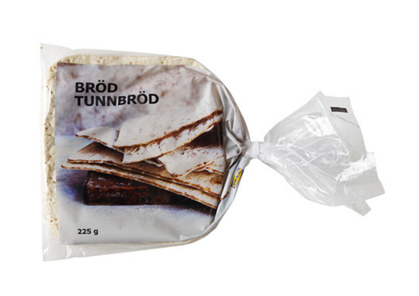 | http://www.ikea.com/gb/en/catalog/products/30228817/ | http://www.ikea.com/ie/en/products/food-beverages/bread-dairy/br%C3%B6d-tunnbr%C3%B6d-soft-thin-bread-frozen-art-30228817/
SKOGSTA  Chopping board, acacia | 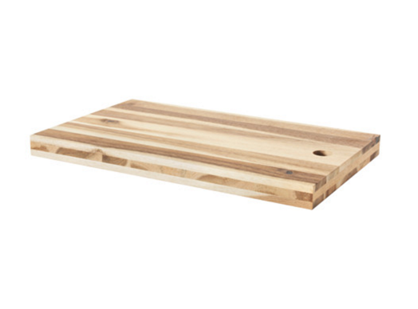 | http://www.ikea.com/gb/en/catalog/products/80305422/ | http://www.ikea.com/ie/en/products/cookware/knives-chopping-boards/skogsta-chopping-board-acacia-art-80305422/
CHOSIGT  Grater with container, blue | 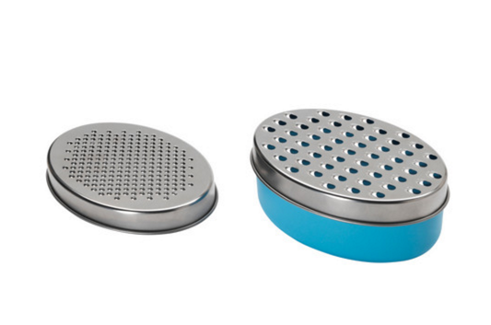 | http://www.ikea.com/gb/en/catalog/products/50153180/ | http://www.ikea.com/ie/en/products/cookware/kitchen-utensils/chosigt-grater-with-container-blue-art-50153180/

